**Vmware virtual machines**

In this lab sheet we will be exploring vmware workstation player 16. Vmware player is a free software that can be used to understand the concept of virtualisation without the issues that come with other software.

**Prometheus preparation**

Before we start we have to prepare our prometheus vm first. To begin I log in with my allocated vm name, in this case vm4 as the username and localhost1 as the password. I then proceed to load prometheus and log in as root. Now I will move onto networking. The vm is not connected to the internet because it needs to be set up as a bridge. To do this I'll navigate back to my host computer, open a terminal and run the ifconfig command. Here I make a note of the ip address for the eno1 network card as I will use this to configure.

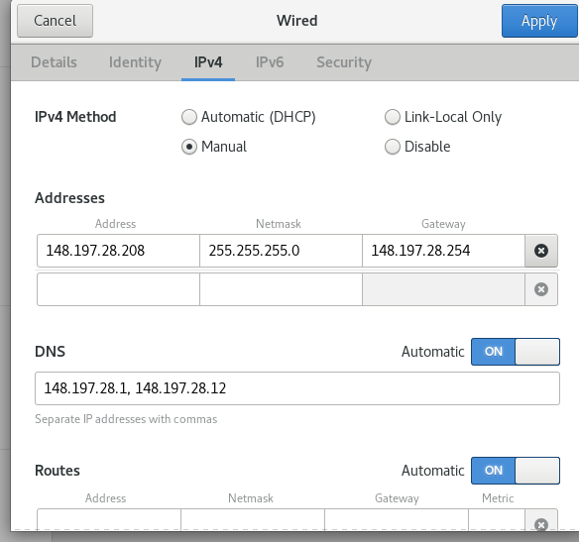

After I navigate to the wired settings and edit the ip addresses and dns as required. To check if the network is properly configured I will attempt to ping google.

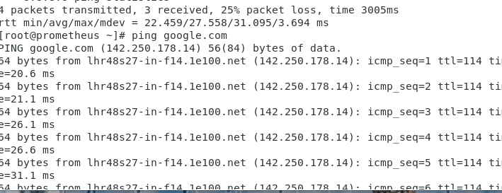

As we can see I can ping google so the network is successfully configured. Next to make sure everything is up to date I will run the yum update command.

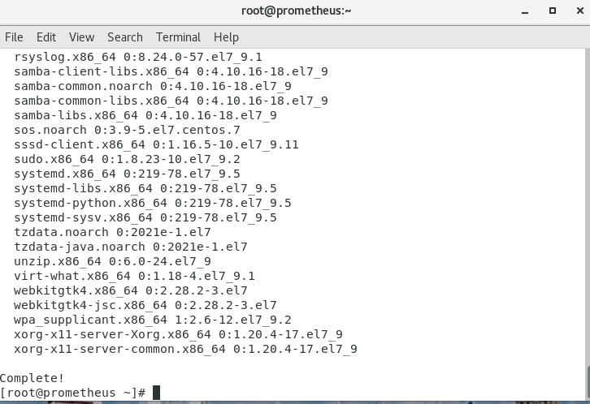

Here all current updates have been successfully installed.

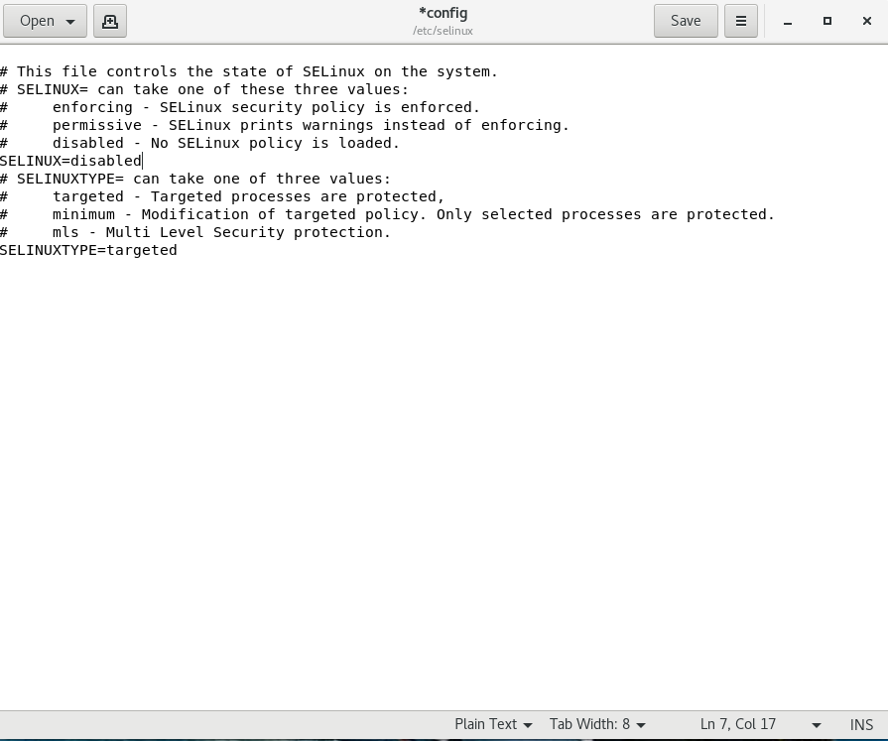

Here I change the selinux from enforced to disabled. I save the changes then run the reboot command in the terminal.

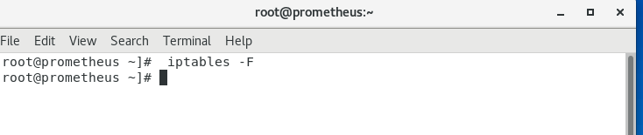

Then I run the following command to disable any firewalls as the firewalls will interrupt with my network.

Now all that's left to sort out is the chrome web browser.

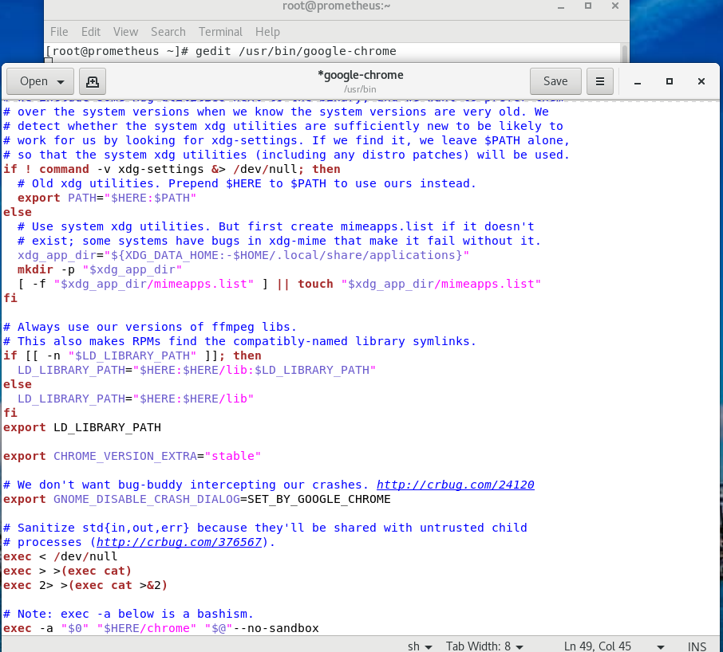

I enter the command into the terminal and scroll to the bottom and add text at the end of the last line.

I then save the changes and double click on chrome.

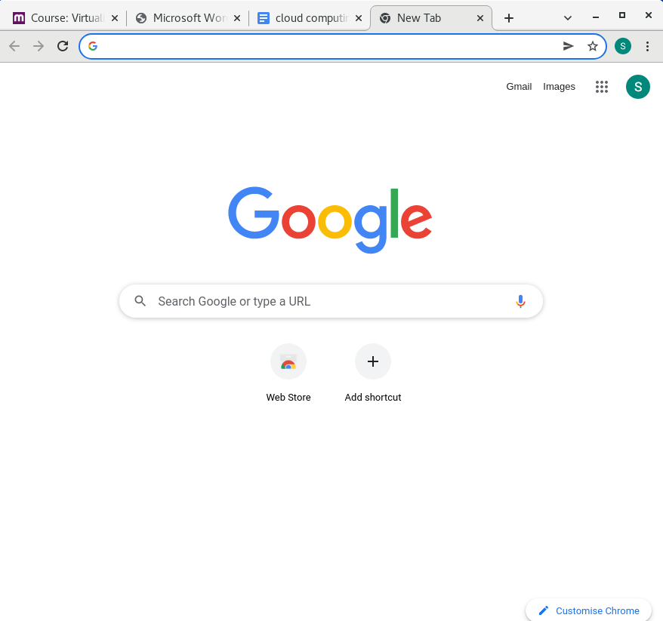

I can now successfully use launch chrome on prometheus.

I then proceed to download vmware for linux. I run the chmod command to change file permissions and begin to install it.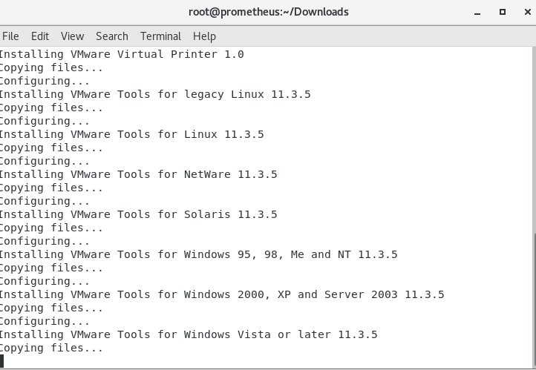

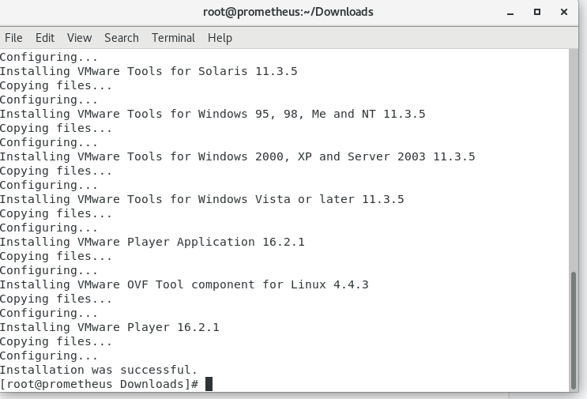

After finishing that I now move on to building my centOS inside the virtual machine.

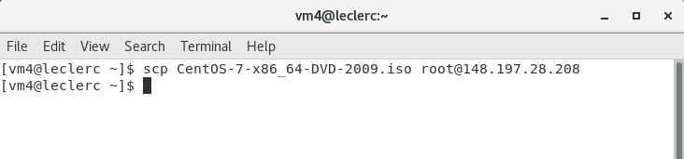

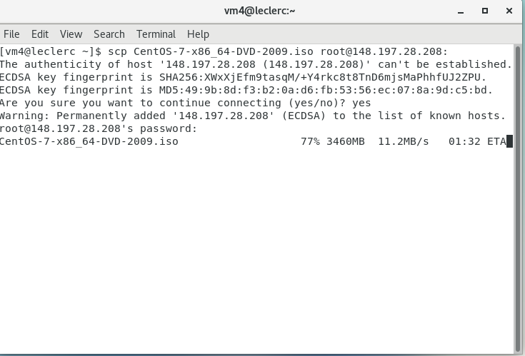

I revert back to the host computer and copy the centos 7 iso by running the command.

After I return to prometheus and invoke vmplayer by typing vmplayer.

Then I begin to create a new virtual machine and modify it to the specified settings.

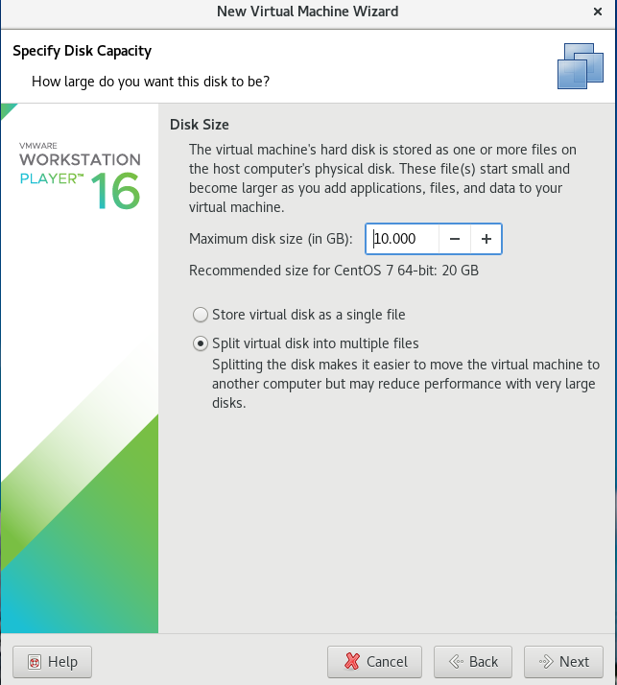

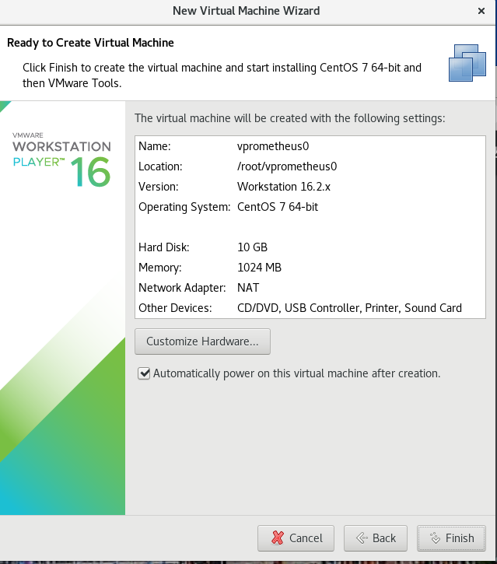

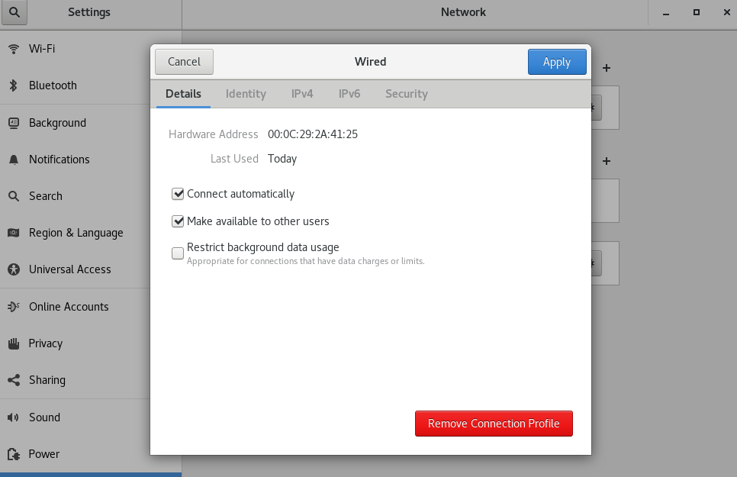

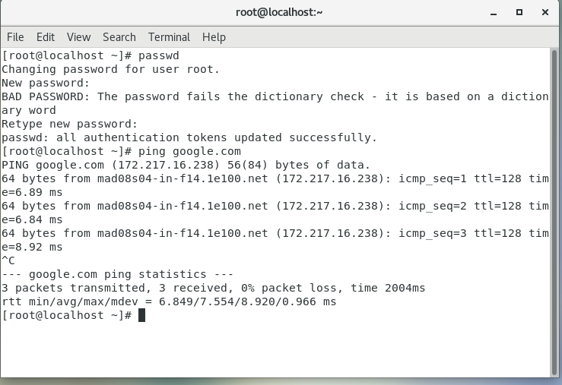

After i've done my configurations,I check to see if i can ping google for connectivity. I noticed however that the hostname is not vprometheus0 so I went into the hostname file to change it.

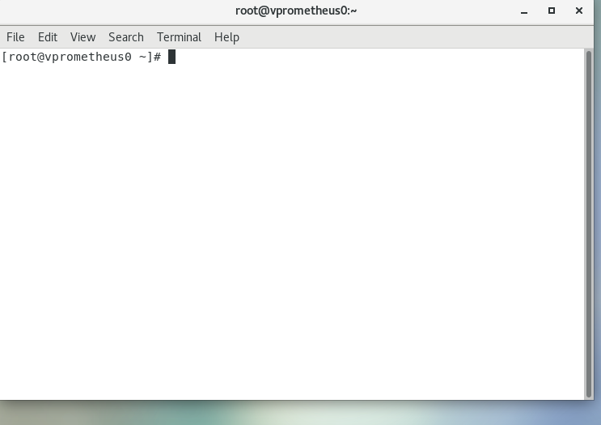

Here the hostname has been successfully changed.

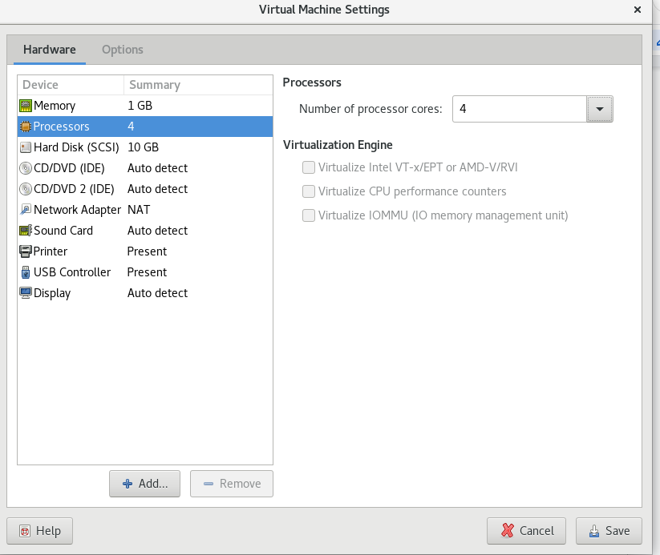

Here I've changed the number of processors to 4 as that's the max my system will allow without it failing.

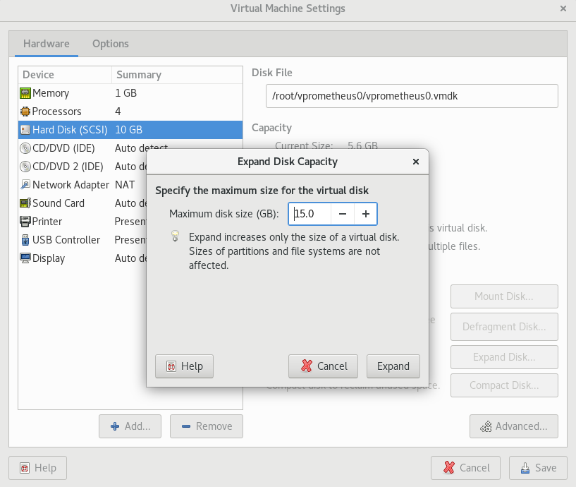

I changed the hdd to 15gb.

Now I am going to explore one of the benefits that comes with vmware. In order to proceed I will require 3 more vms however I can simply clone the original one.

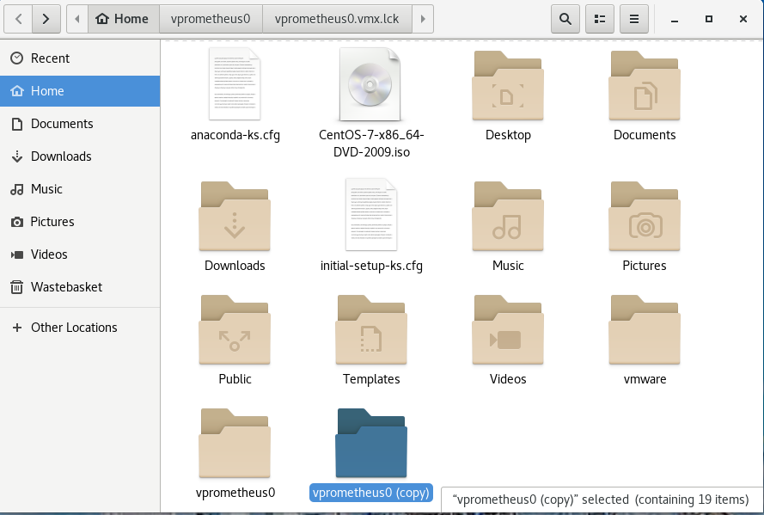

I right click the original folder then paste.

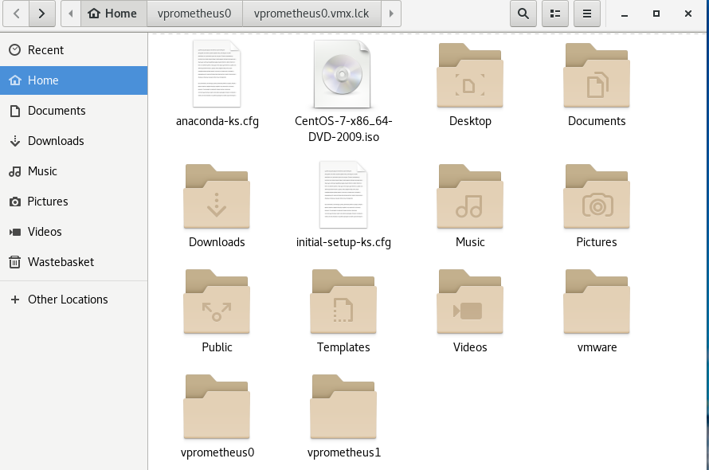

I rename it to vpromethues1 to differentiate between the two.

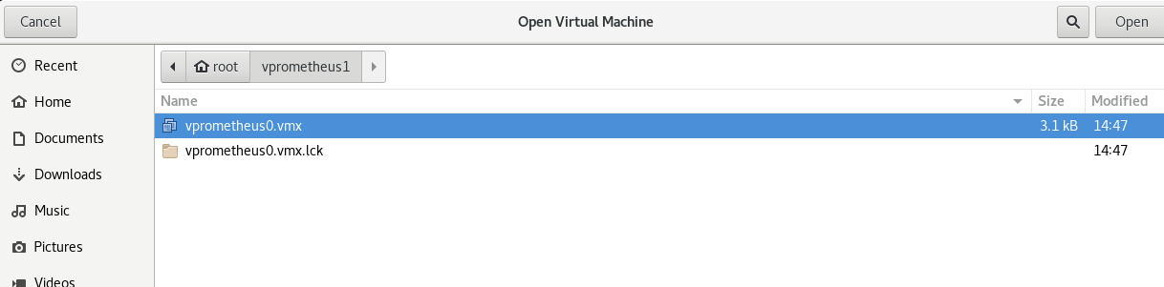

I then open a terminal and type vmplayer to start another instance of the software. I select the new vm with the file ending in vmx and open it.

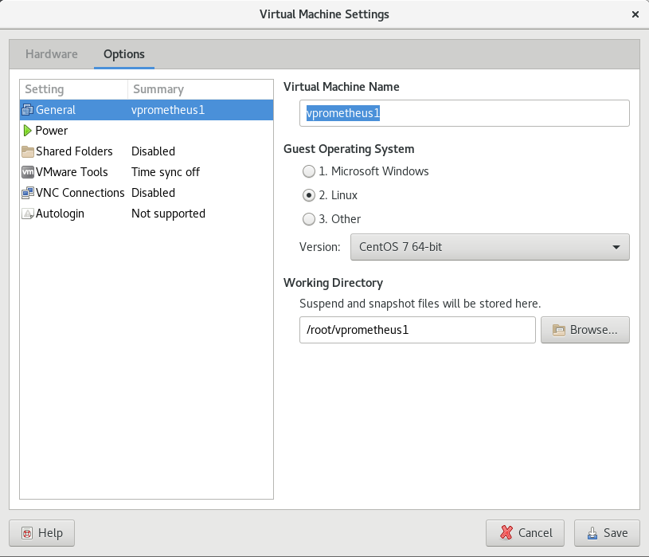

I rename the vm.

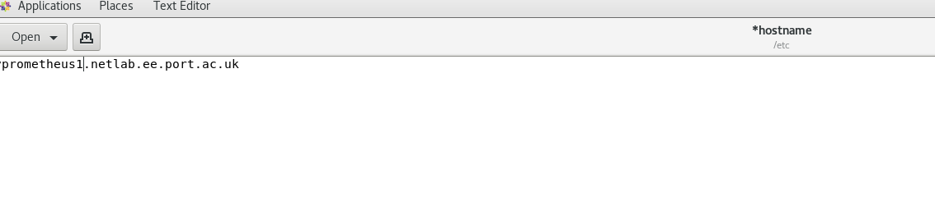

After I finish the configurations I rename the hostname as well.

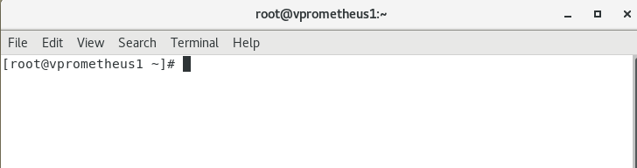

Here it has been successfully updated.

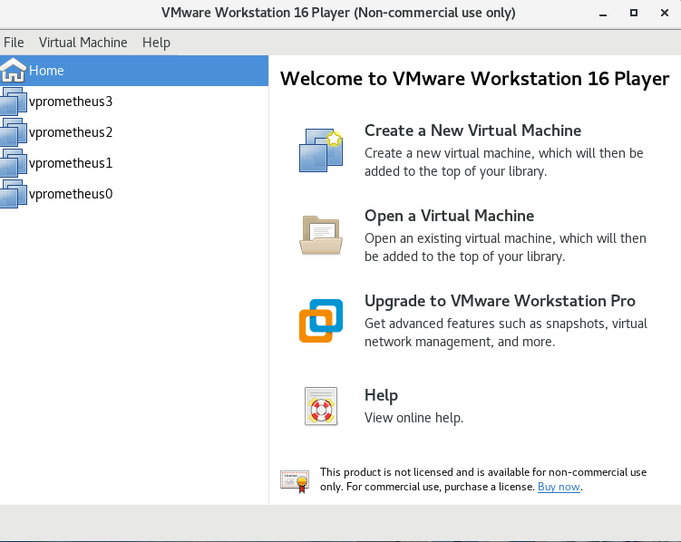

I repeat the process 2 more times.

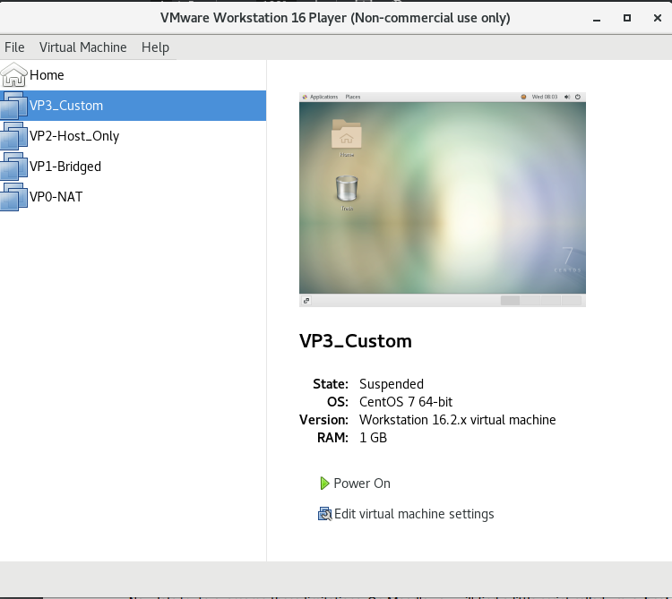

I then rename the vms

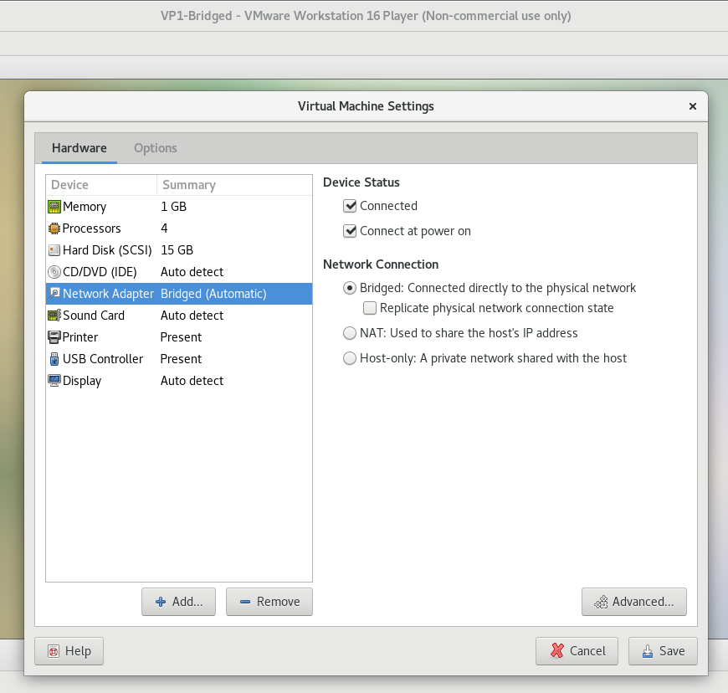

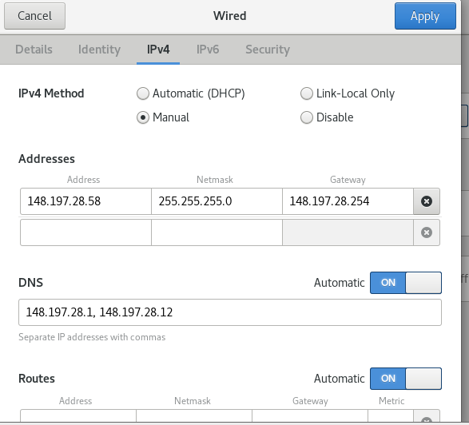

For the vpromtheus1 I set the network adapter to bridged. I then set the IP addresses for the vm as well.

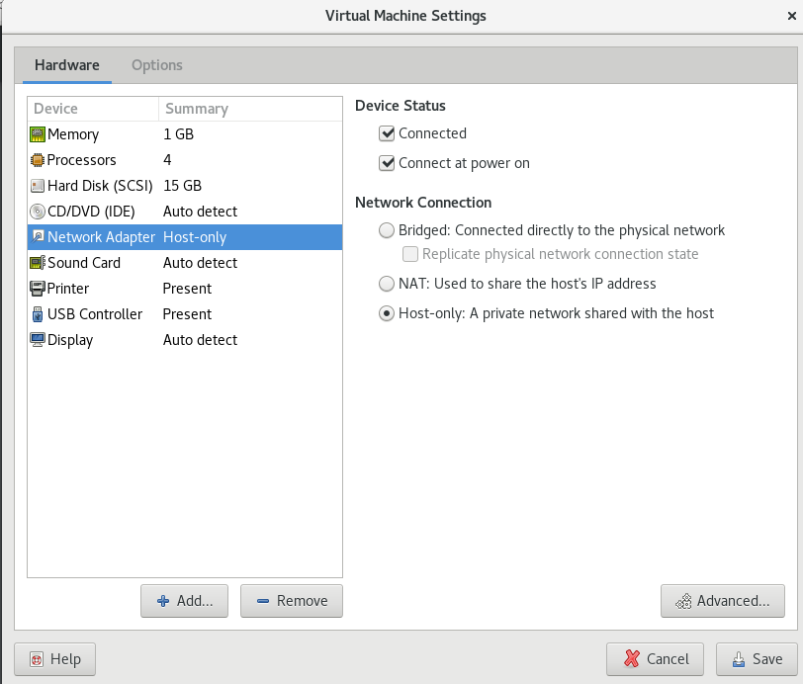

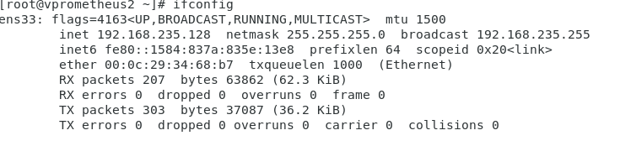

For the vpromethues2 I didn't have to set an ip address manually. An ip address was automatically allocated to it. To double check I used the ifconfig command. I Also set the network adapter to host only. The host only is unable to ping other vms or even google.

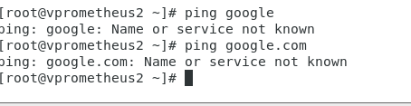

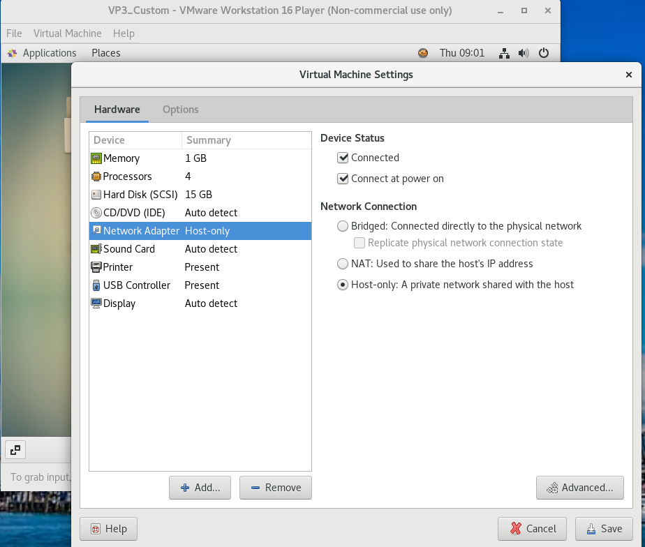

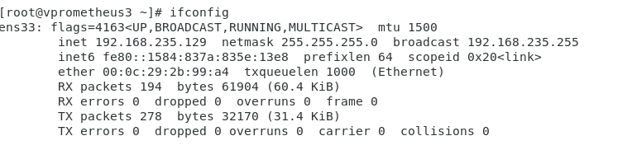

Here I also set vm3 to host only and it has also been assigned an ip address.

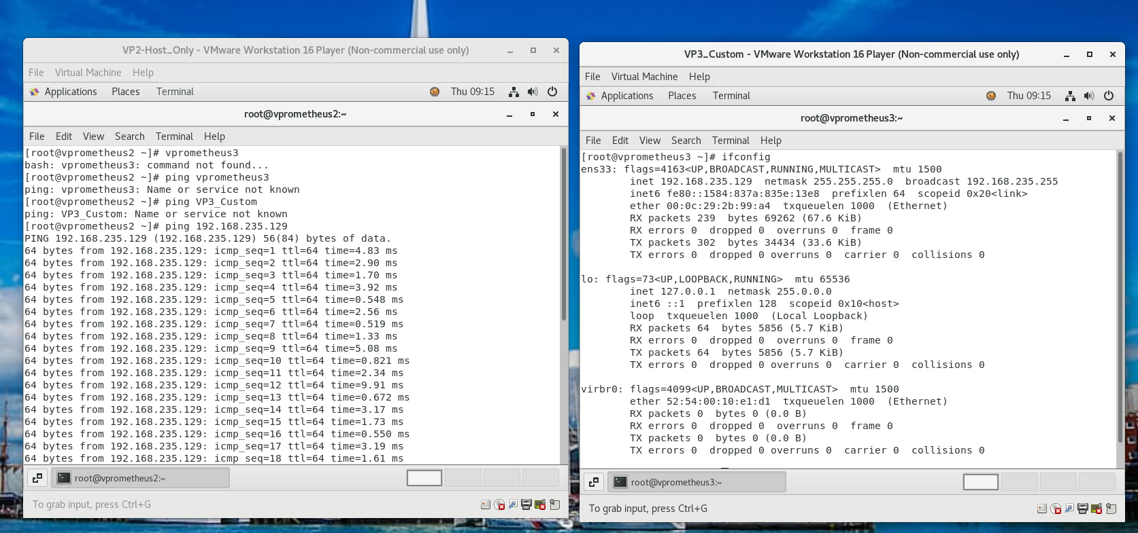

Above you can see that I'm successfully able to ping from vp2 to vp3.

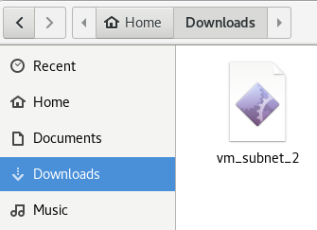

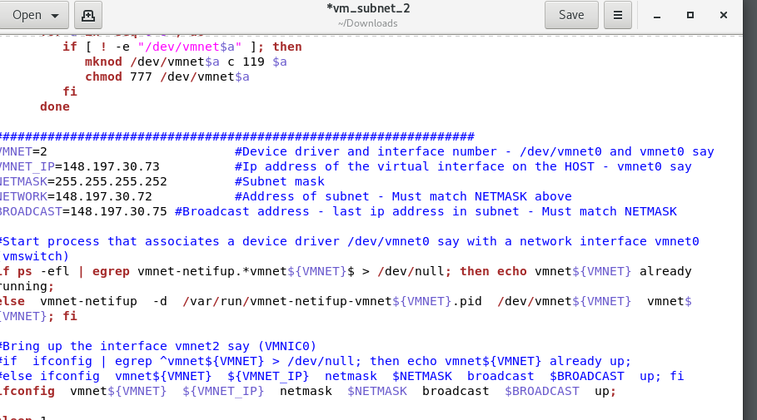

Here I download and edit the vm_subnet_2 file. This is the first step in overcoming the limitations of host only networking.

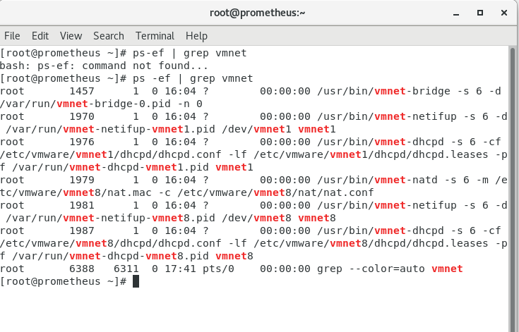

I run the following command and it shows me the current processes with vmnet.

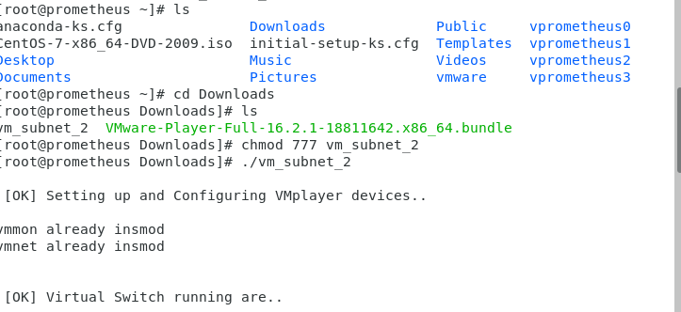

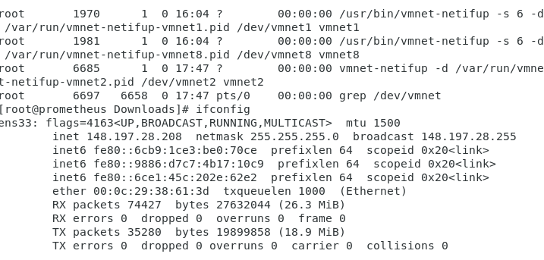

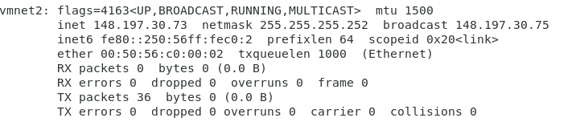

In the terminal I run the script and navigate to where the file is stored. Now, vmnet2 has been created with the configurations that I made in the file.

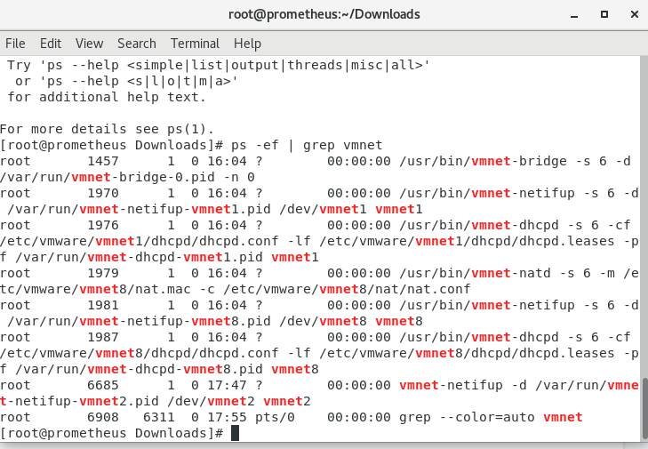

I run the ps command again and as wee can see the processes for vmnet2 have been added.

Now i will set the virtual network card for vprometheus3.

First i will need to have the option to select a custom network card. The first step to do this will be to download a file form moodle and save it.

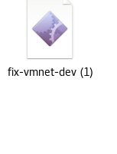

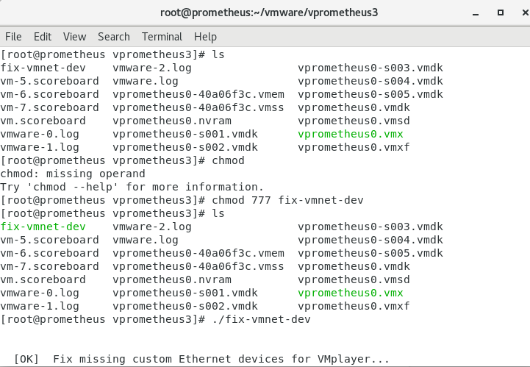

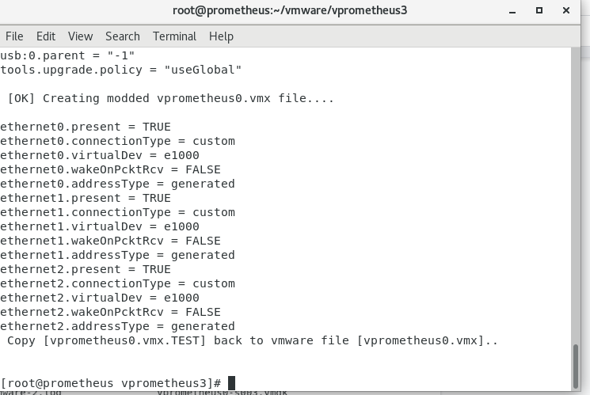

Here i run the file using the chmod 777 command and ./.

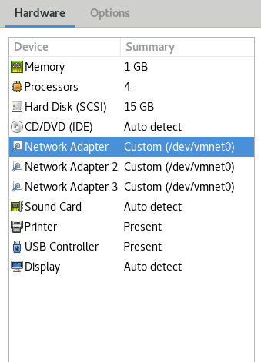

As you can see now I have three network adapters. I only need one so I deleted the other 2.

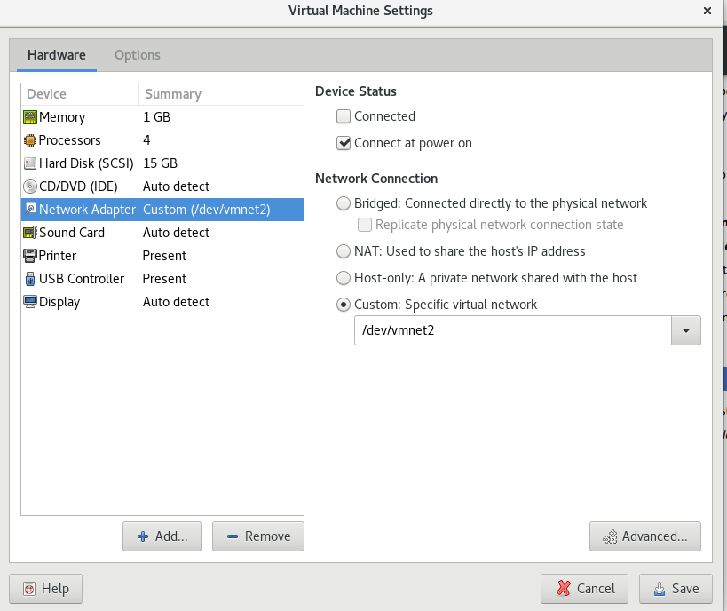

Then I set it to vmnet2 and boot vp3.

The benefits of vmware tools are they can better the performance and utilisation of the vmware and add more functionality.

The difference between suspended guest and power off guest is when you suspend, the current state and processes of the machine are saved to a file; whoever with power off guest, the vm is shut down. This is the same as turning off a physical computer.

Virtualize intel is technology that helps with supporting virtualisation of the processor. Virtualization intel helps with isolating different hosts on a single processor.

Virtualize cpu performance counters are lines of code that analyse and monitor events in software which can help to identify patterns and improve cpu performance.

Virtualize iommu is the virtualization of iommu or intel. Because of this virtualisation, it can block direct access to memory.

The file size in vp0 changed because there was more virtual memory space available because of virtualization.

Bridge mode is a configuration which disables nat on a modem. It also allows a router to work as a dhcp server without the issue of corresponding ip addresses.

**Conclusion**

In this lab sheet I have successfully undergone the utilisation of virtualization. I have set up Prometheus and 4 different virtual machines. I've managed to increase storage space for some of the vms and create connectivity between them and the outside world as well.

**lab sheet 2 virtual box**

**Introduction**

In this lab I will be delving into virtual box. Virtual box is the second biggest virtualisation tool used after vmware. Virtual box is very powerful and easy to use with alot of community support for any issues that arise.

**INSTALLATION**

First I need to install a virtual box. Then I simply click on the link and install the RHEL7 version.

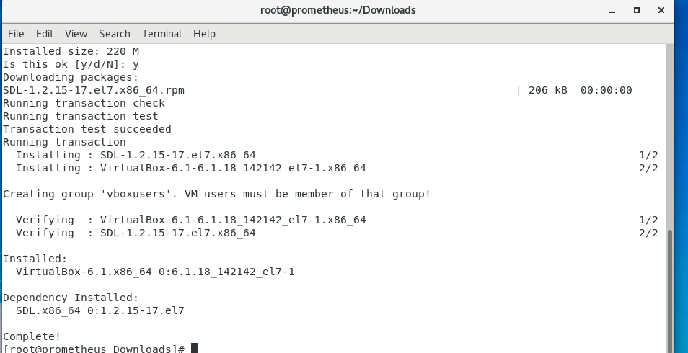

I navigate to the downloads directory and run it.

**Building a vm**

Now I will move onto building a centos client in the vm.

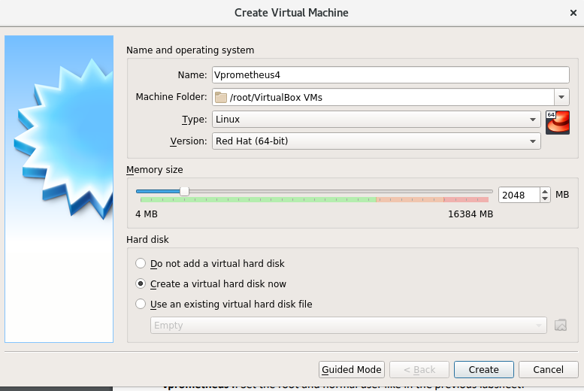

I configure it to what is specified and click create.

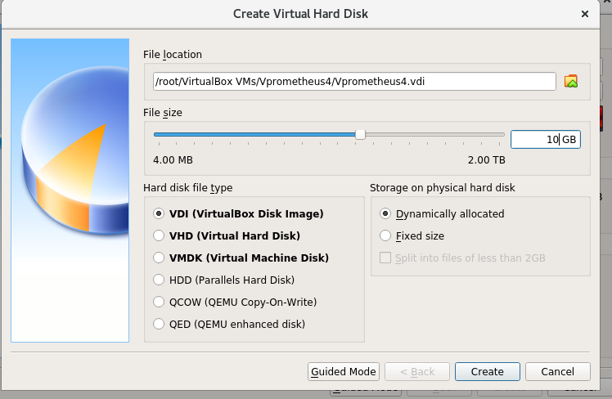

Vdi is the default format for the virtualbox. Thi is used when someone creates a new virtualbox file.

Vhd are virtualized hard disks that operate identically to the physical hard drive when mounted.

Vmdk is a format of a file that describes containers for virtual hard disk drives to be used in vm.

Qcow is a file format for disk images and uses a strategy of optimization which involves delaying allocation of storage until it is actually needed.

Qed is a disk image format that uses applications found in the qcow format with a preference of better performance and data integrity.

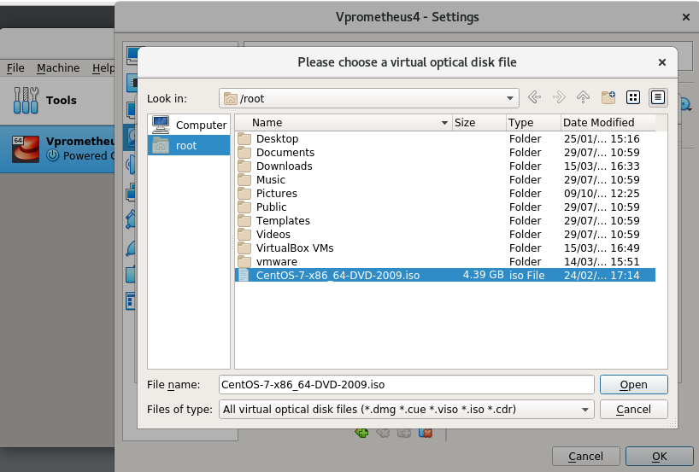

The vm is now created.

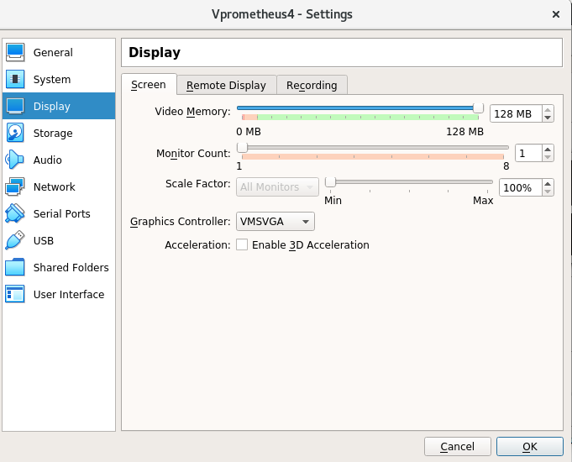

For better performance I increase the video memory to its max.

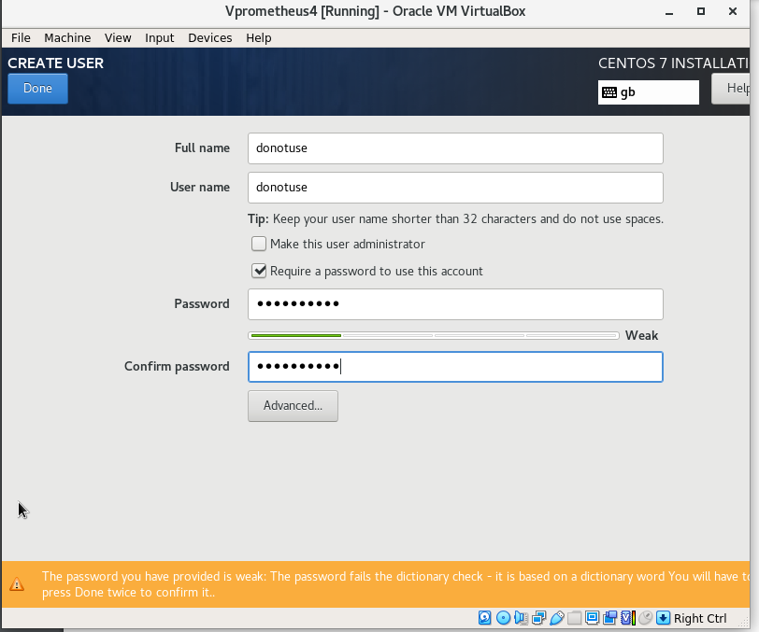

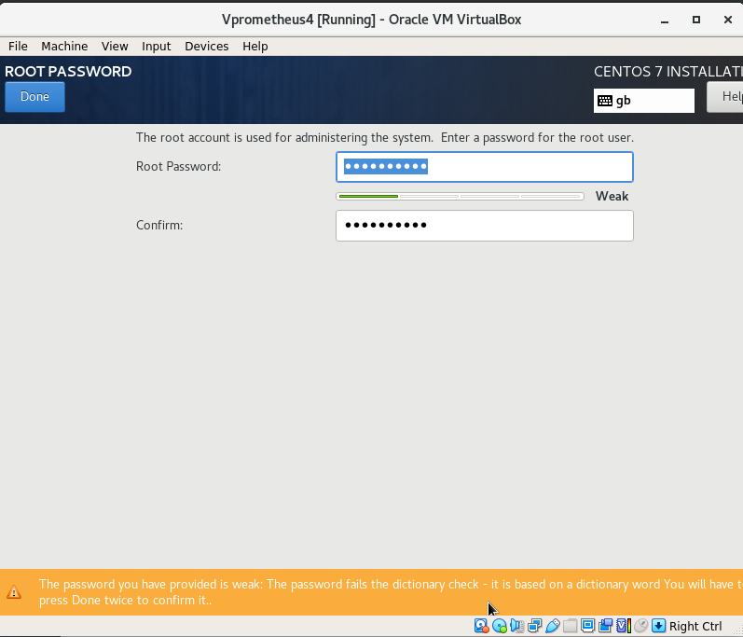

I changed the hostname and set the root password to localhost1. I also created an account that will never be used.

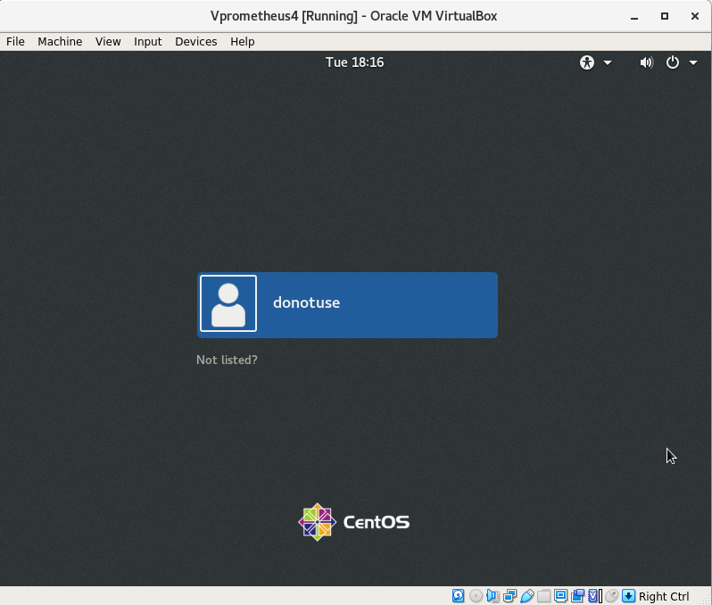

After installation was finished, i reboot and log in.

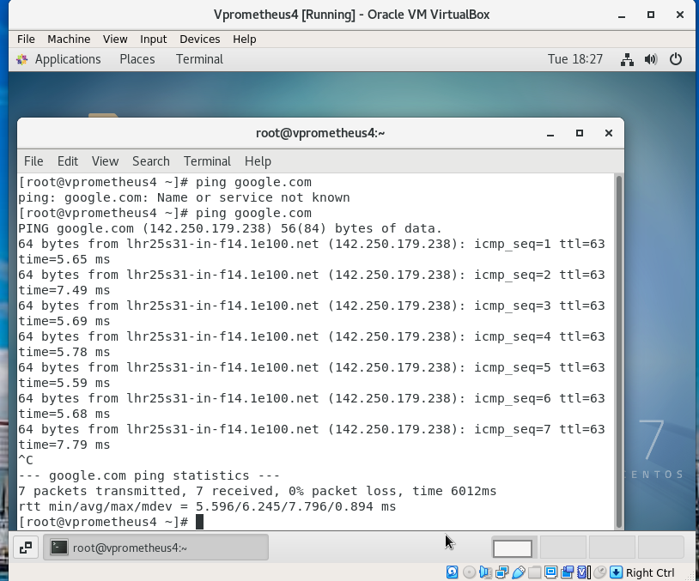

To check for internet access I turn on the network card and set it to automatic. Then i ping google.com and successfully the ping works.

**VIRTUALBOX AND VIRTUAL MACHINE SETTINGS**

Now that i have a working virtual machine I will now explore what information i can gather and the settings i'm able to change. I will also see how much of a real computer it imitates.

I navigate to the file virtual media manager.

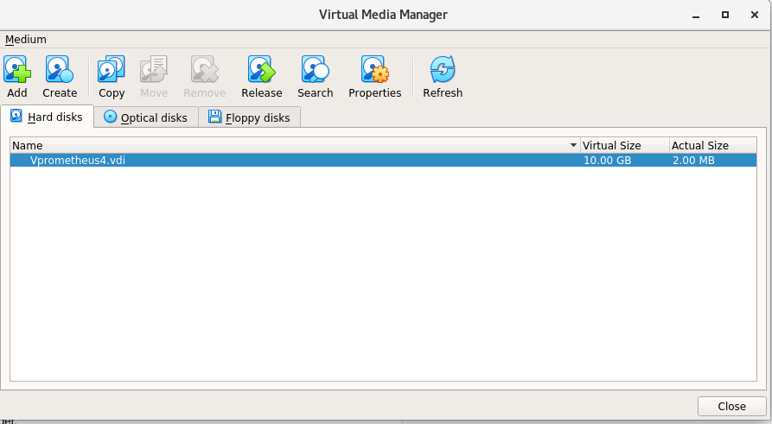

The virtual media manager lets me add, create and copy a virtual hard disk image. I can also view the virtual and actual size of the image along with its properties.

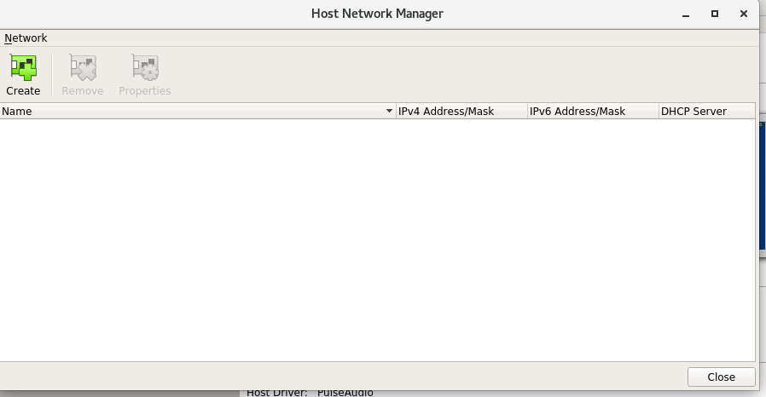

Within the host network manager I can create, remove or view the properties of a host only network.

**Virtual box networking**

Currently my vm is connected to the outside world using a nat configuration.

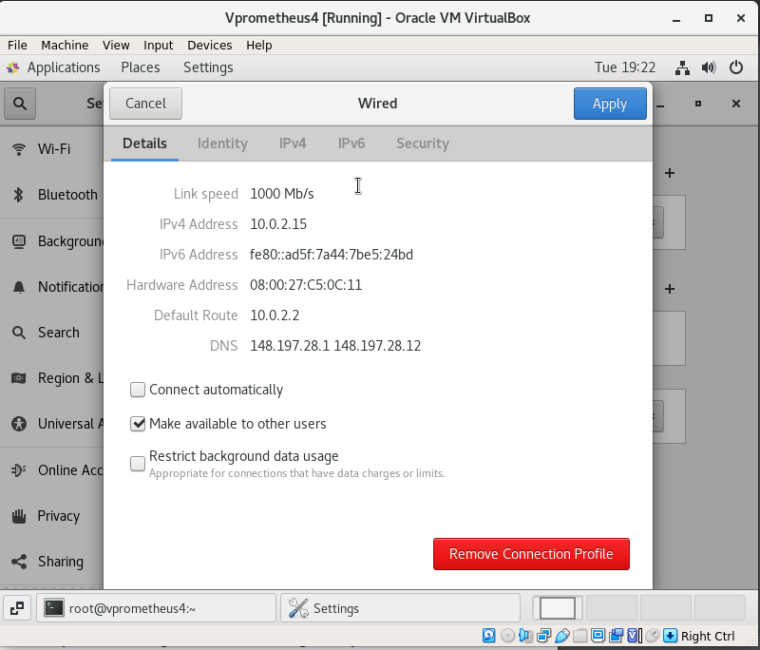

Here we can see my ip, default gateway and dns server. In order for me to test the network options ill need 4 more vm but thankfully i don't have to repeat the process of creating them i can simply clone them.

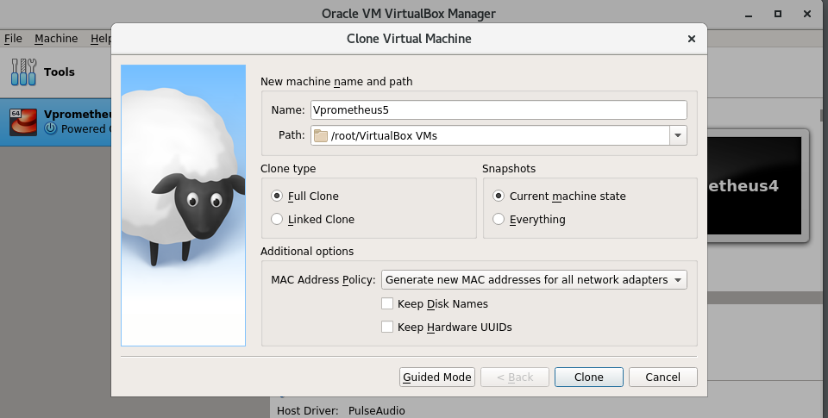

I rename the vm to vp5 and change the mac address policy so that a new mac is generated for all network adapters. Then I select clone.

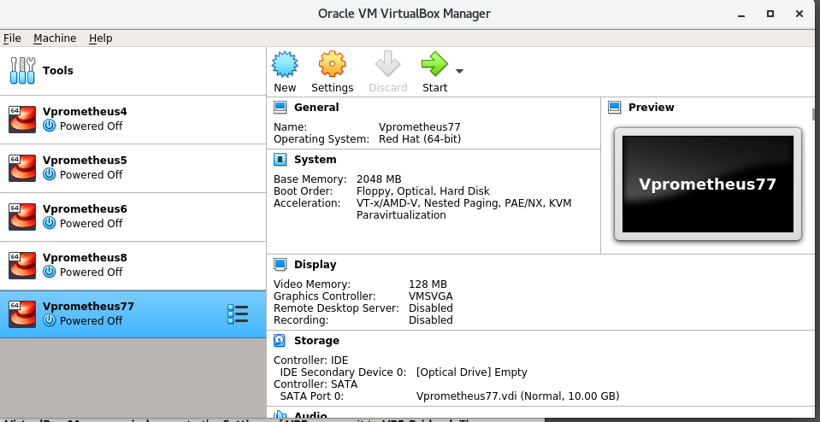

I repeat the process 3 more times.

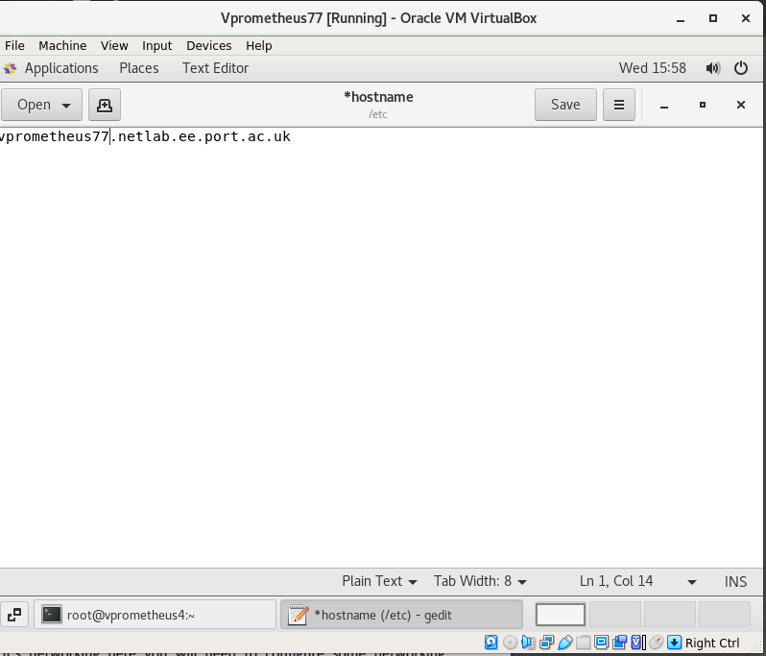

I change the hostname for all of them as well. Now that that's done I will begin to experiment with them one by one.

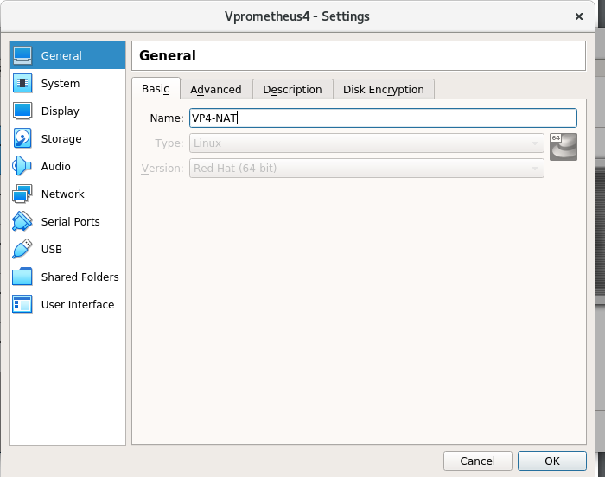

I change the name.

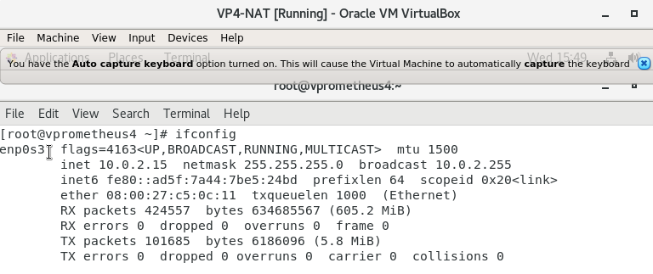

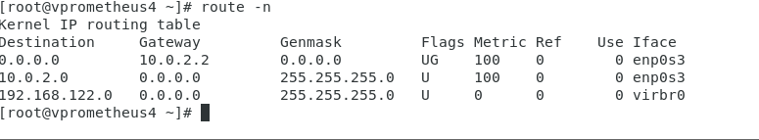

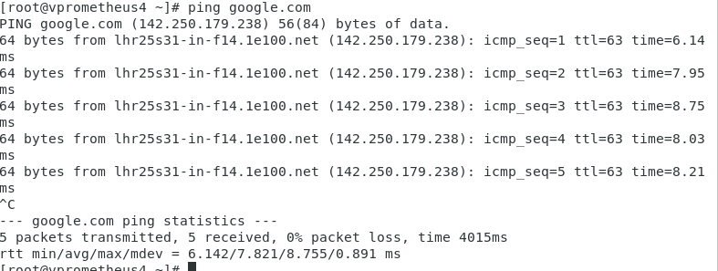

From the screenshots we can see my ip, default gateway and my connectivity to the internet.

I move onto vp5.

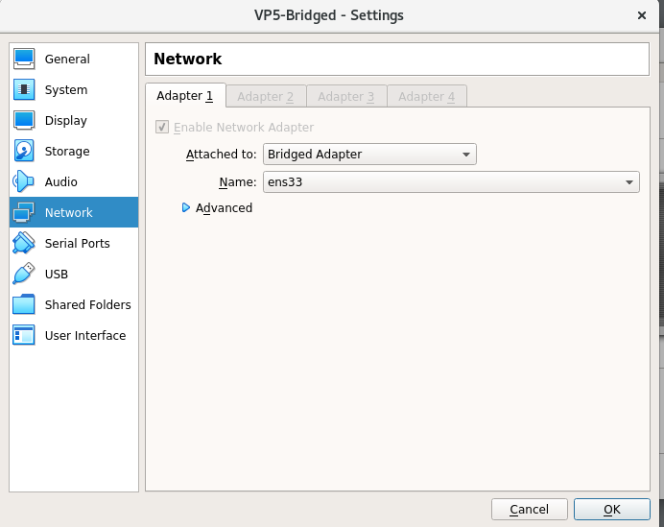

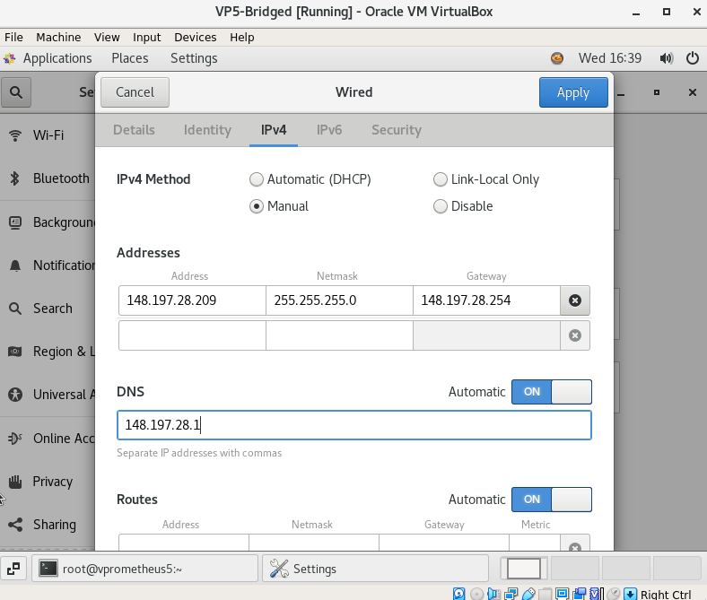

I had to manually assign the ip information as there seemed to be an error.

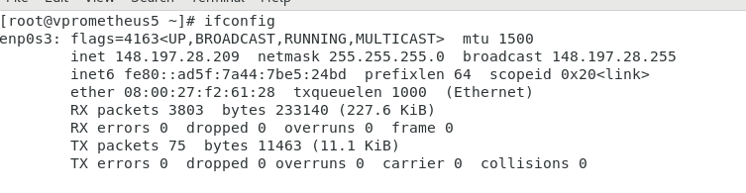

And it's been successfully set.

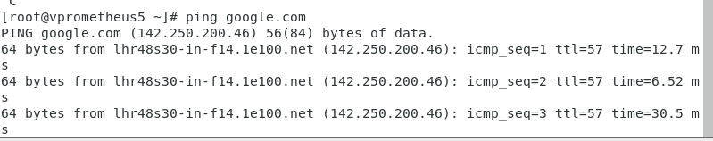

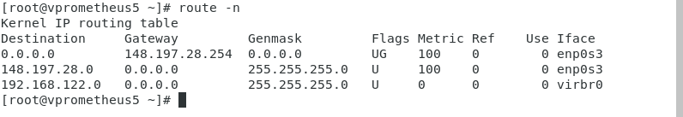

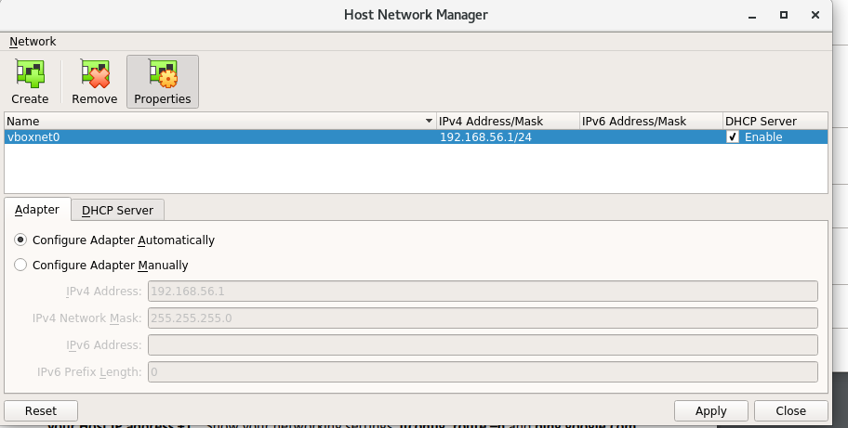

.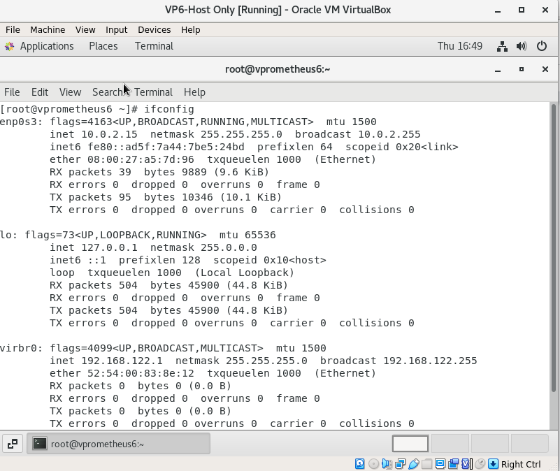

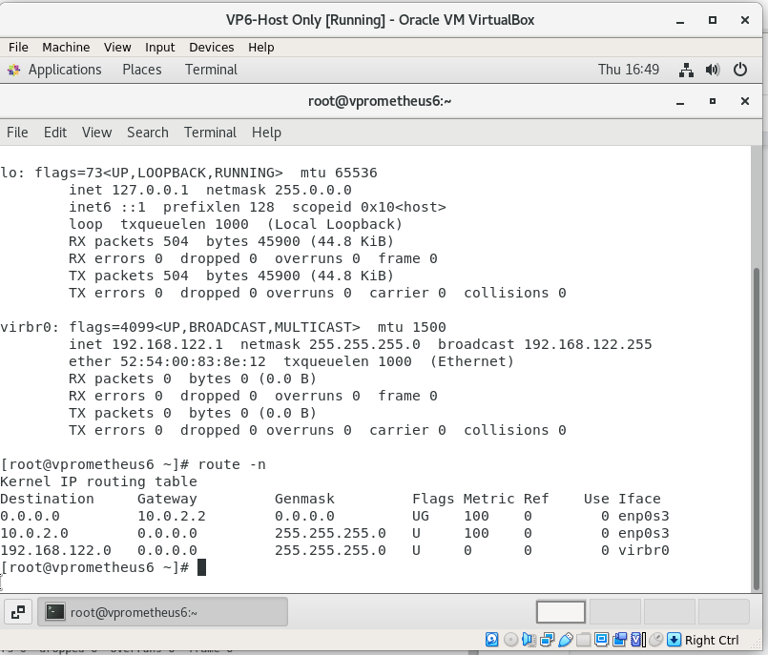

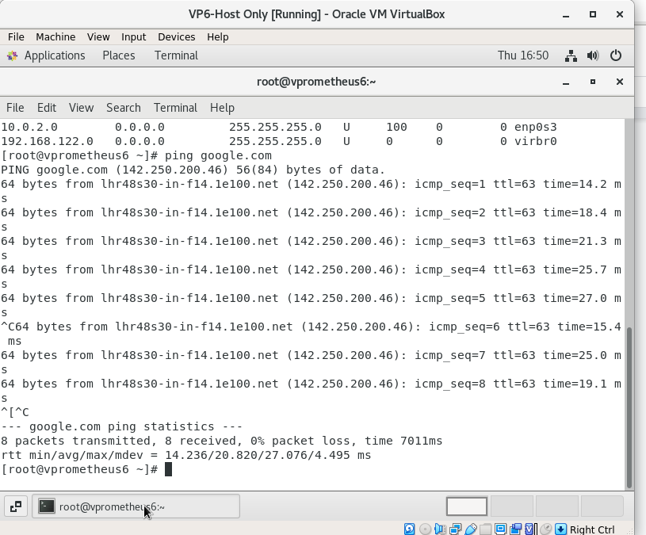

From the screenshots above you can see my route table,ip address and I can successfully ping google.

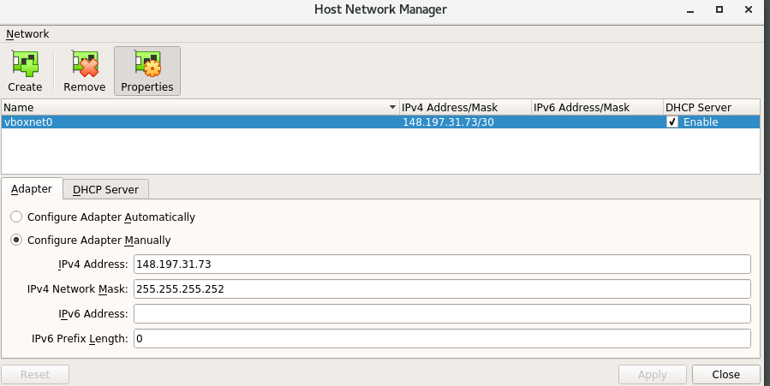

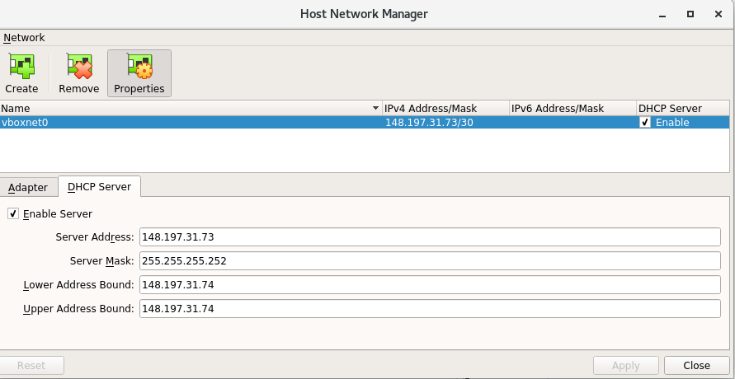

Here I customise the ip addresses for vboxnet0.

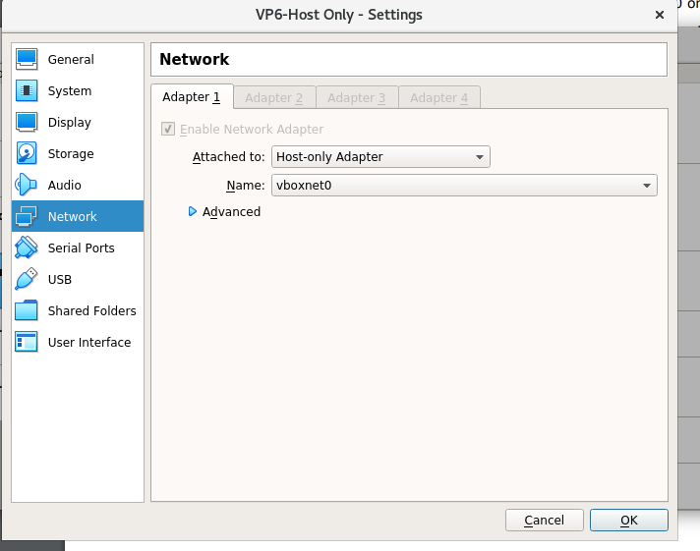

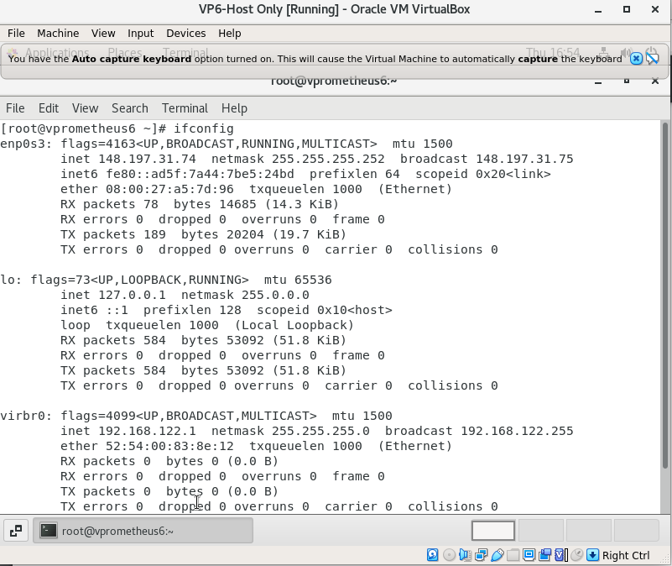

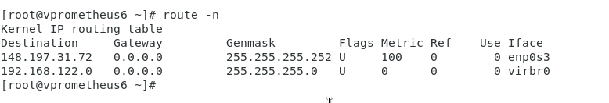

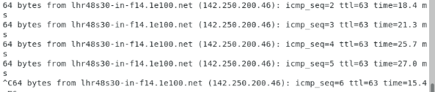

From the screenshots above you can see the ip address route table and google being successfully pinged.

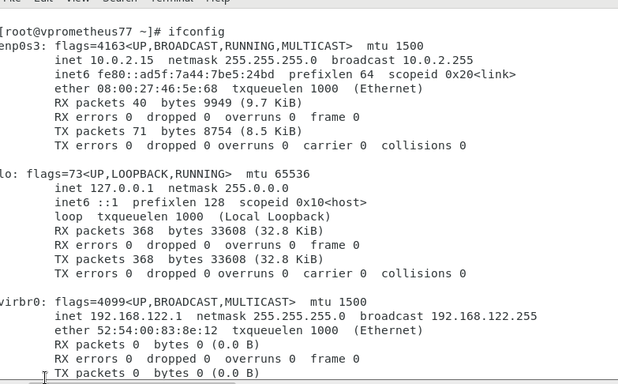

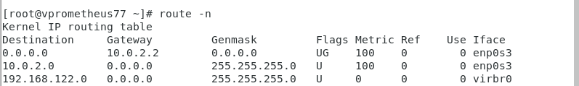

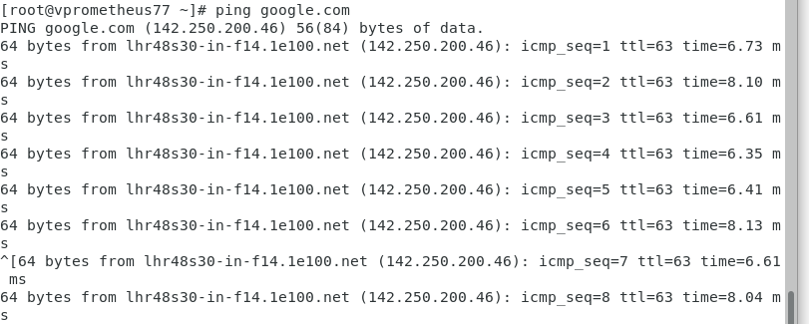

Here we can see if the ip address,route table and google being successfully pinged for vp7.

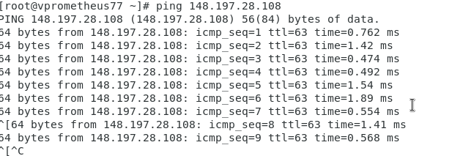

I can also successfully ping prometheus.

**Conclusion**

From this labsheet I have been successfully able to utilise oracle virtualbox to create virtual machines and ping between them. I've also been able to connect to the outside world and prometheus itself.

**Open nebula**

Open nebula is a cloud based platform. This is used for managing a data centre's virtual infrastructure. Because it's open source it allows us to build a cloud that we can use for central management. In this lab sheet I will be installing an open nebula and utilising its tools.

**installation**

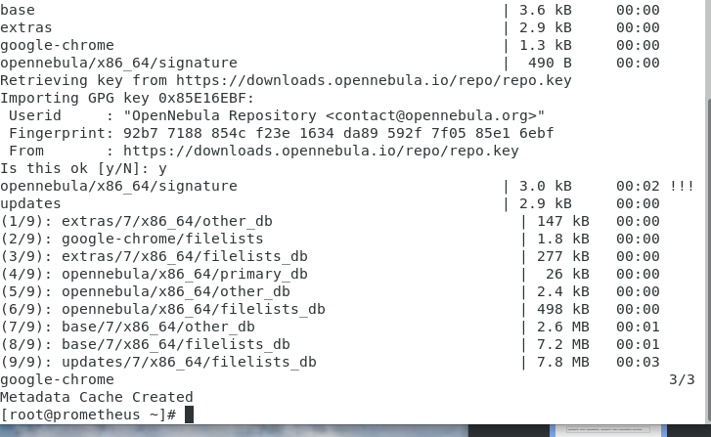

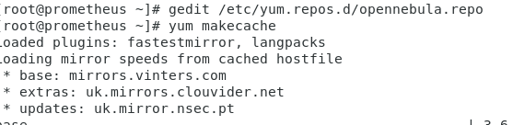

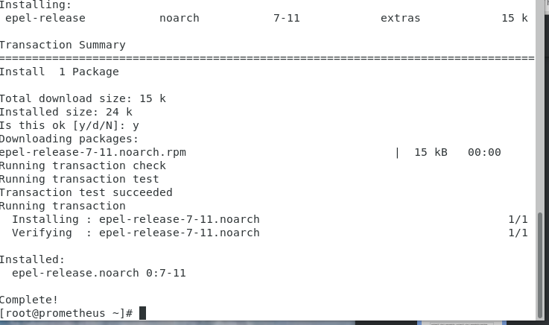

First I install open nebula repositories using the commands in the screenshots above. Then I activate the epel repo.

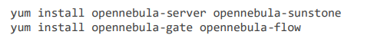

After I run these two commands to install packages from my repository for the open nebula front end.

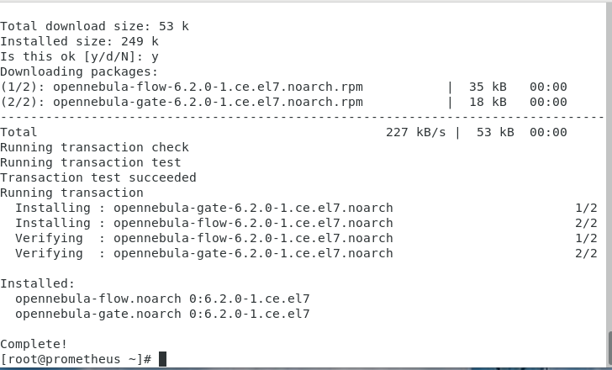

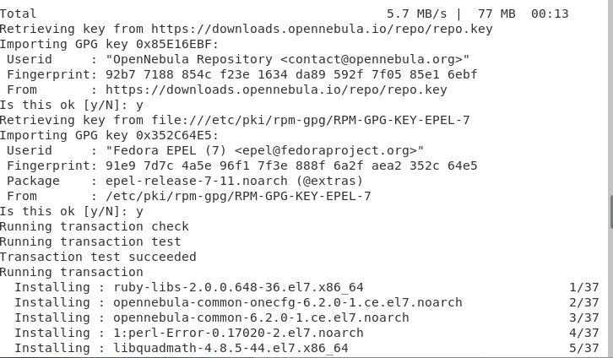

**Starting open nebula**



Here I've logged In using sudo and used the echo command to output the contents to the file. Oneadmin is the username and localhost1 is the password.

Before running the open nebula services i will disable the fireedge gui as i will be managing the cloud through sunstone.

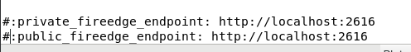

Here I comment out the last two lines.

To confirm open nebula has been installed i run the following command to show me details about the user.

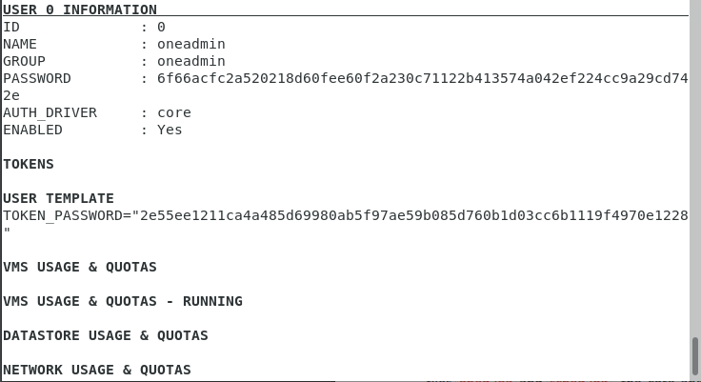



From this I can gather that open nebula has been installed successfully.

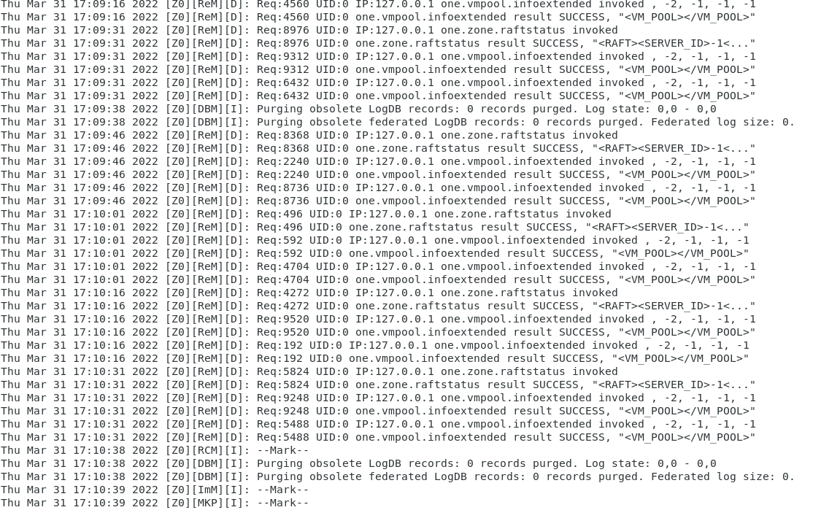

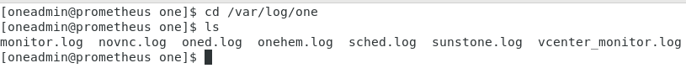

Here Ive navigated to the oned.log file and scanned it to check if there were any errors. Thankfully there wasn't.

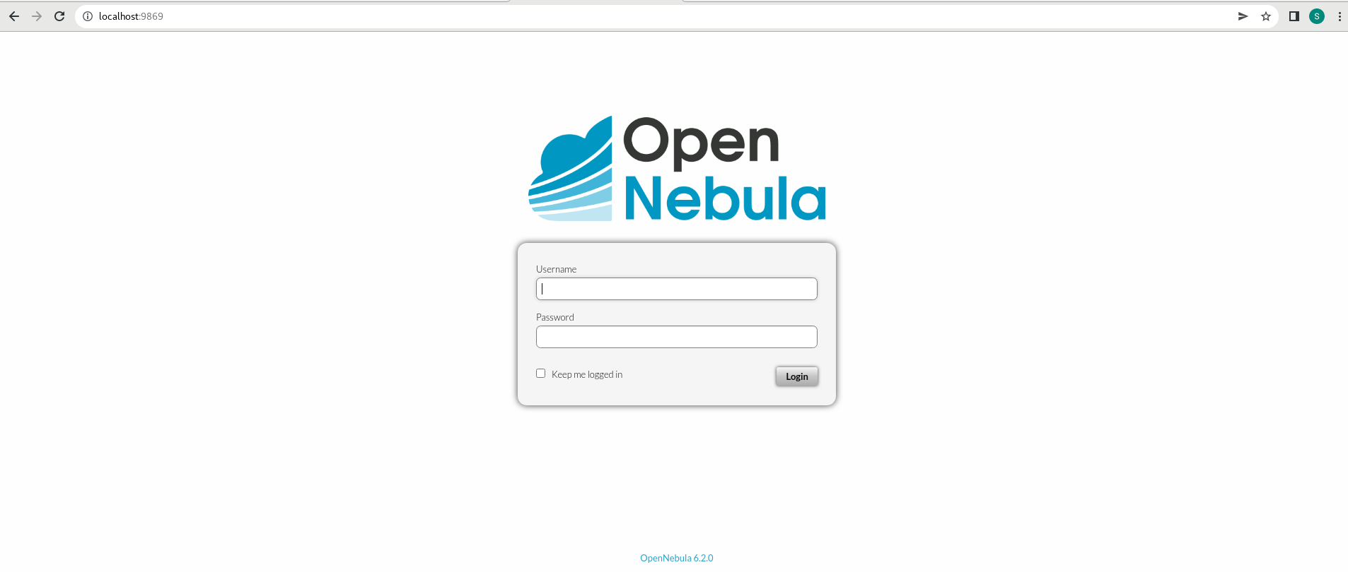

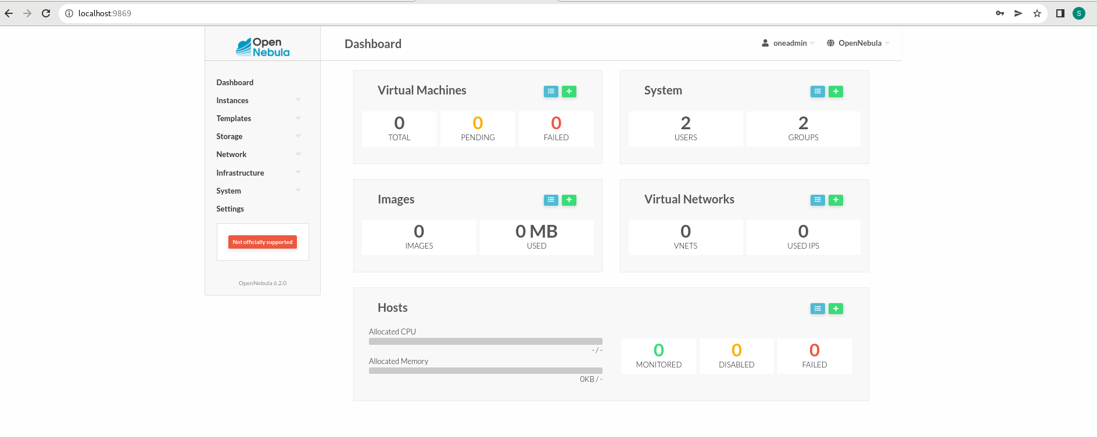

Now i can log into the sunstone web interface. From the screenshots above, I pointed my browser to the address and I was prompted with a login page. I entered oneadmin as the user and localhost1 as the password.

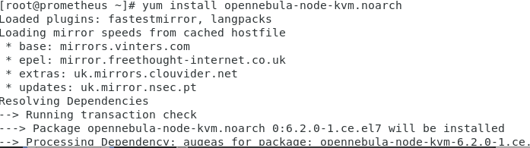

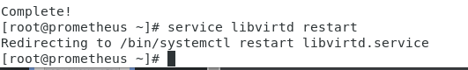

I run the following commands in order to install the node package and restart libvirt to use the open nebula configuration file that was provided.

Now i will change the password settings with opennebula so that it can ssh password from any node.

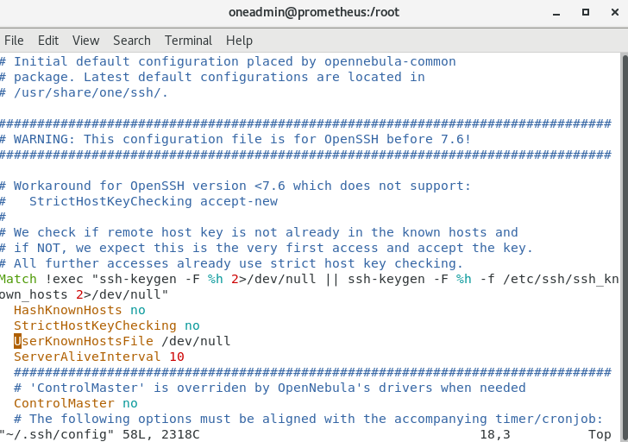

In the figure above I have added configurations so that a key isn't needed.

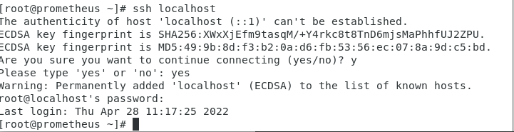

Successfully from the figure above it has been set.

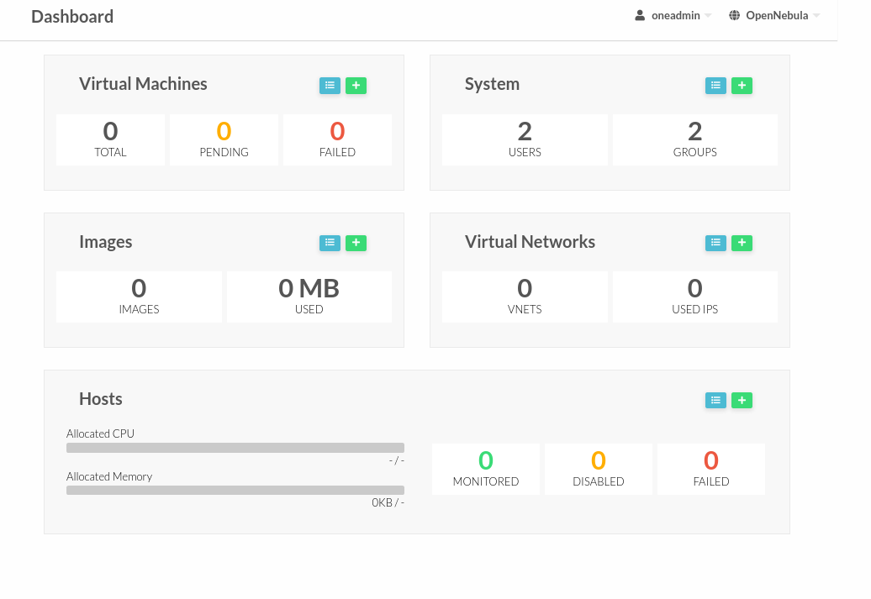

In the dashboard area I can see from the figure there's two users and two groups.

Conclusion

From this labsheet I have been able to setup and install open nebula.

**Sunstone vm creation**

In this lab sheet I will be interacting with the sunstone web interface by building my own cloud vm. To do this I will need to configure a network,host and create an image and template.

Create the host bridge

Firstly i will need to have my main interface connected to a bridge.

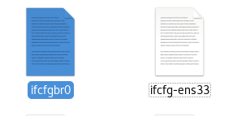

From the figure above I have renamed a copy of ifcfg which I will use as a bridge to connect to the vm.

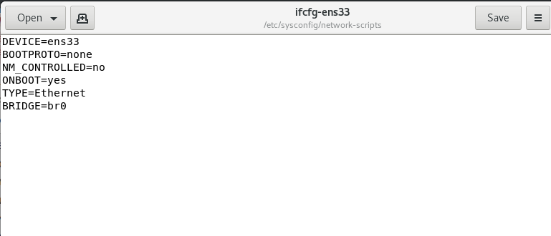

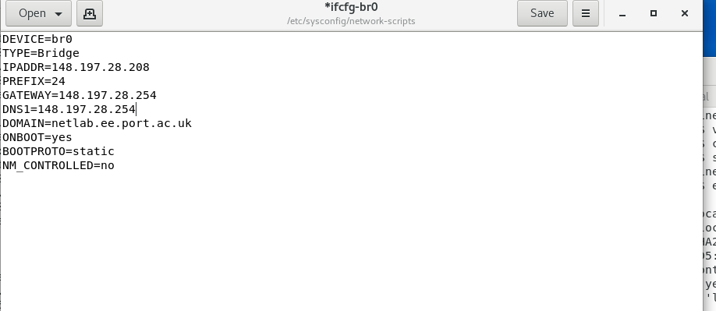

From the figures above I have made the relevant changes to the necessary files.

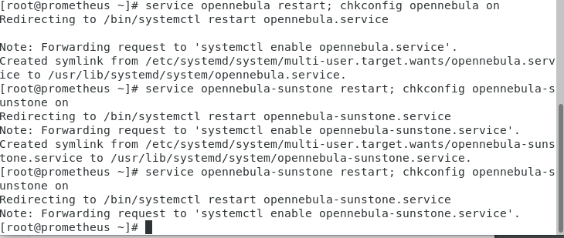

I entered the following commands. This will ensure sunstone is running and configure the services to run automatically.

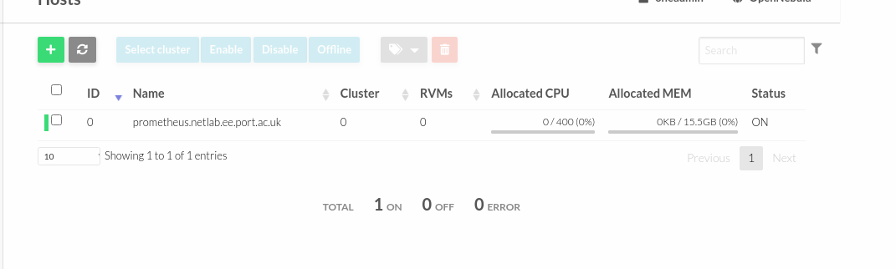

Here i Have created a host.

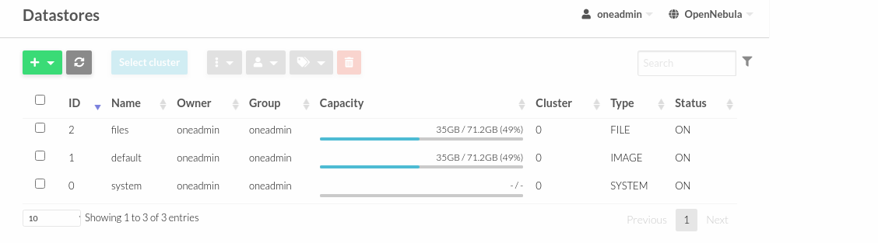

I've checked the data stores and there are three datastores already there.

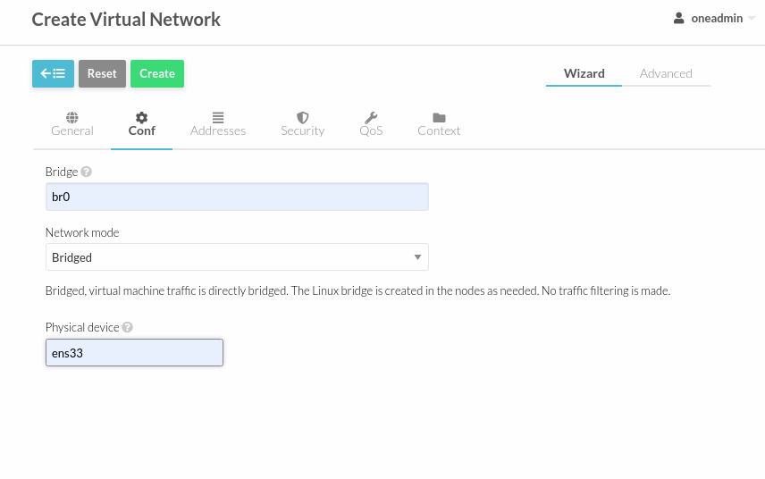

In the figure above I created a new network and called it bridge.

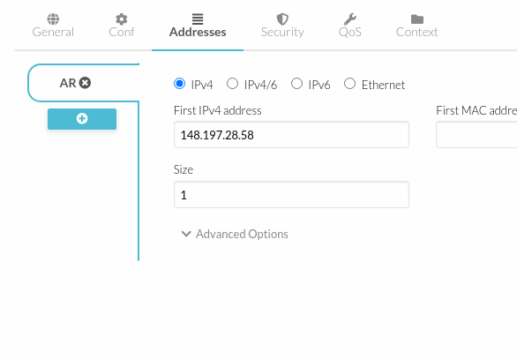

Here I have set the ip address and the size.

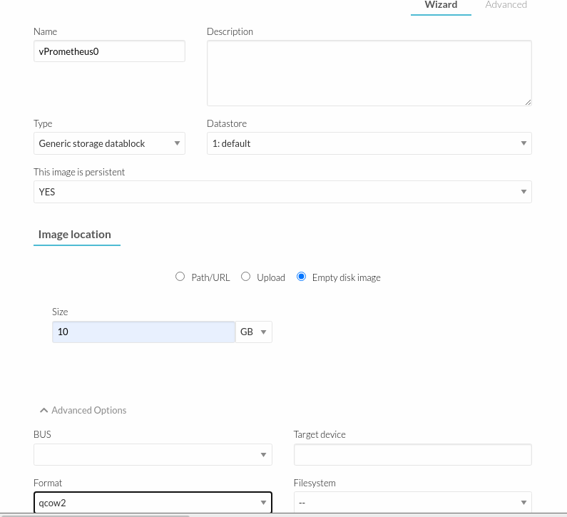

I will need to create two images. One for hard drive space and the other to build the operating system.

Above I have made the necessary requirements for the first image.

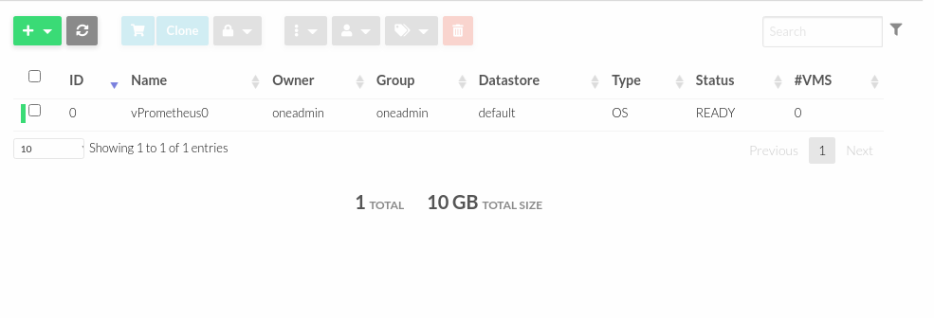

Above I have created the first image.

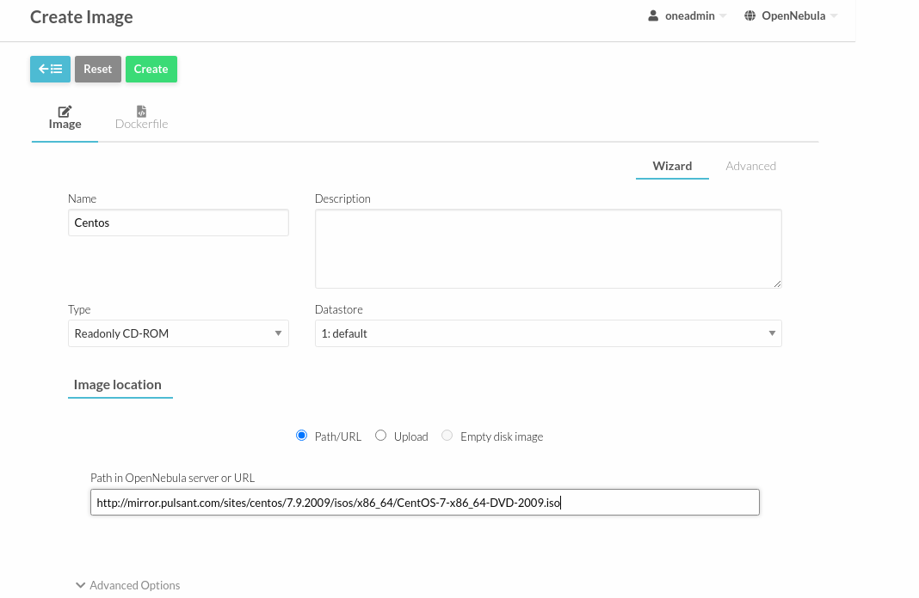

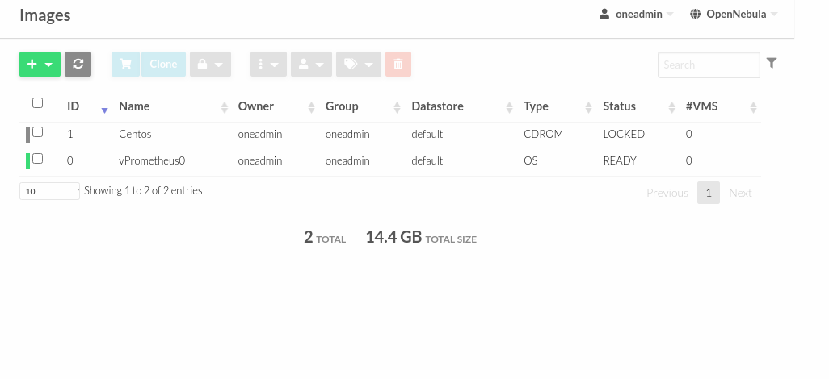

Above I have created the second image.

Now i need to create a template for my vms.

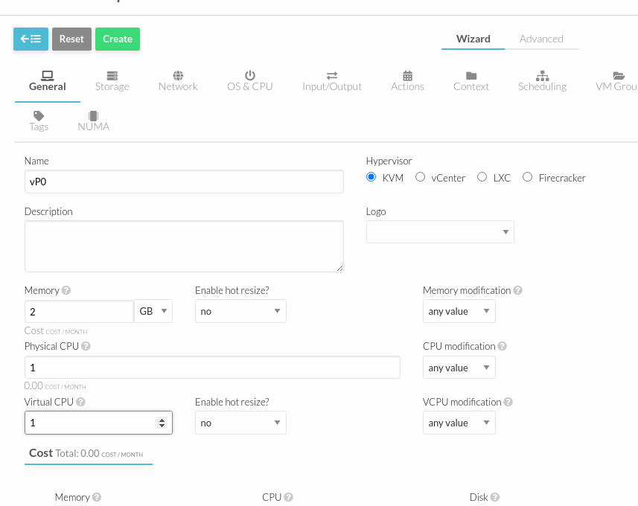

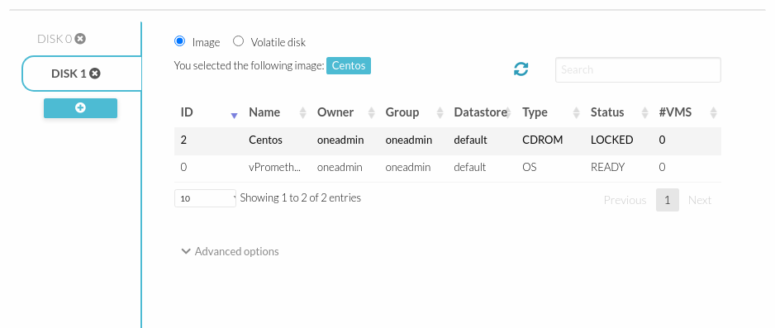

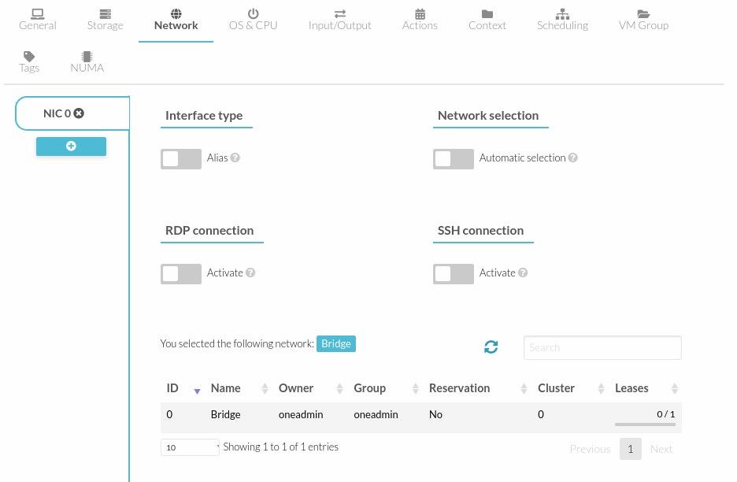

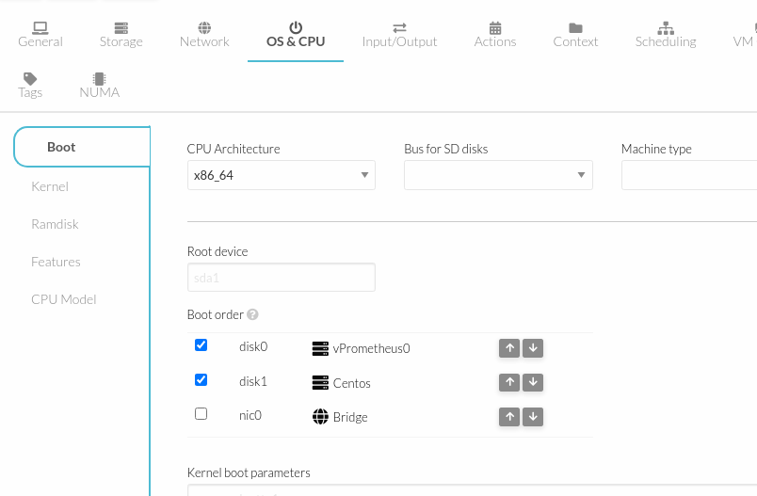

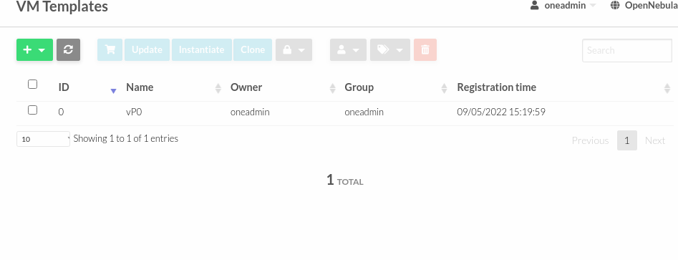

From the above images, you can see I've made the relevant changes in order to create the vm template.

Now that all these steps are done I will now add a virtual machine.

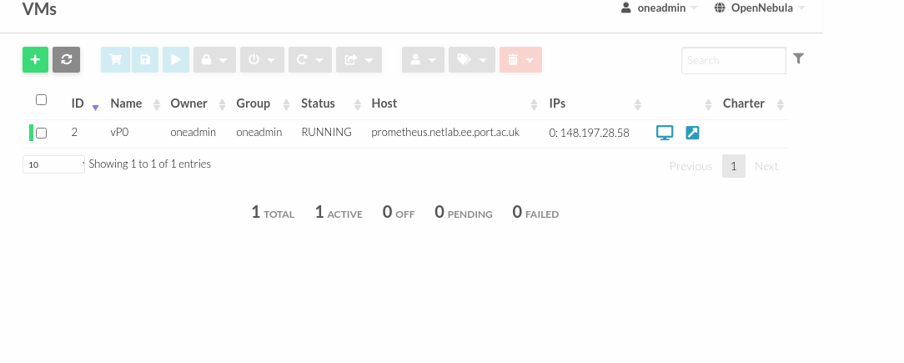

Above, the image shows successfully how I have created a vm.

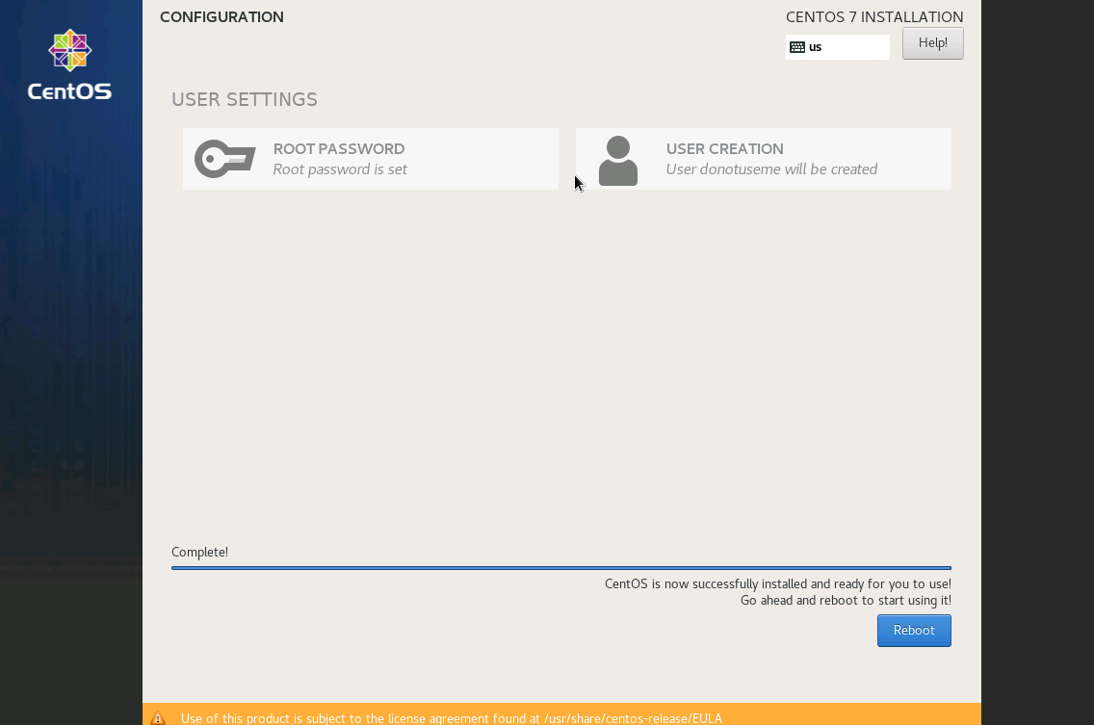

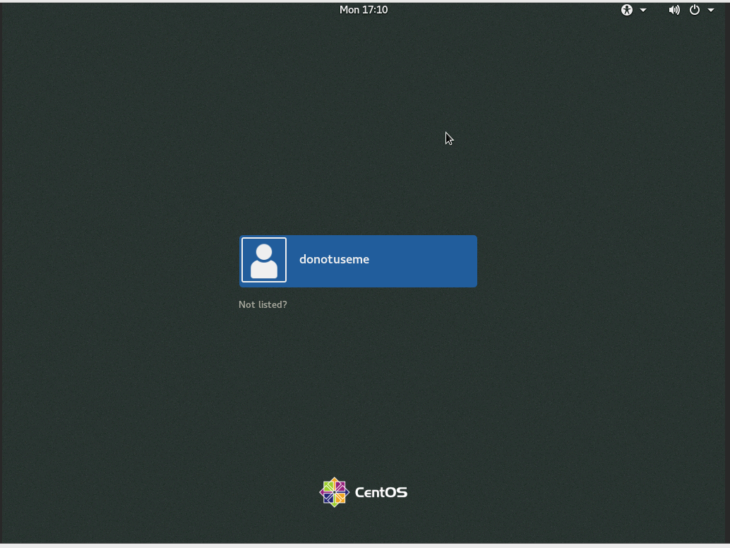

From the images above I have successfully created my first computer within the cloud.

Conclusion

From this lab sheet I Have been able to create my own computer within the cloud. I've created a custom virtual machine and configured and created settings in order to do so.

**Open nebula networking**

Within this labsheet I will be familiarising myself with the opennebula networking infrastructure. To do this I will be configuring the network interfaces that are required.

**Ovs installation**

First I will be using openvswitch. This is an open source software of a virtualized multi layer switch. It is licensed under apache 2.0. Its main purpose is to provide massive network automation. Its other purpose is to support distribution across multiple physical layers.

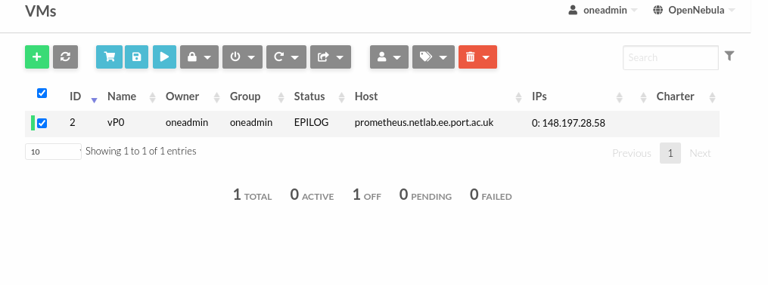

The first step ws for me to terminate the vm which I did in the image above. In its place I will be creating new networks.

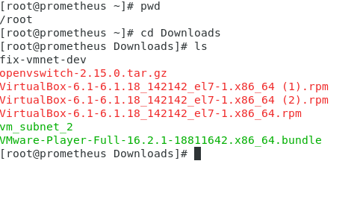

Above I have downloaded openvswitch as you can see its saved within the download folder.

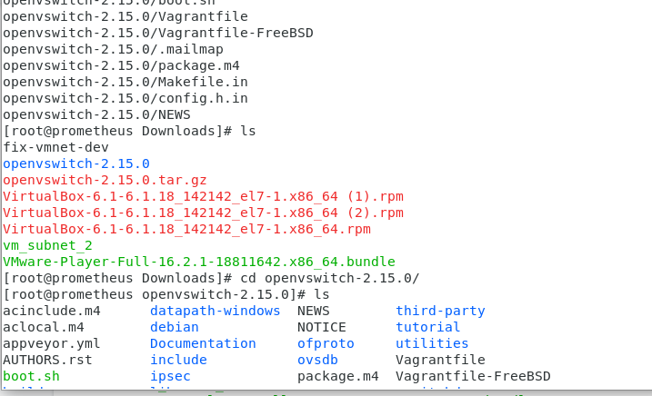

From the image above I have extracted the download. I then proceeded to change the directory into the folder as that is where I will need to run my commands.

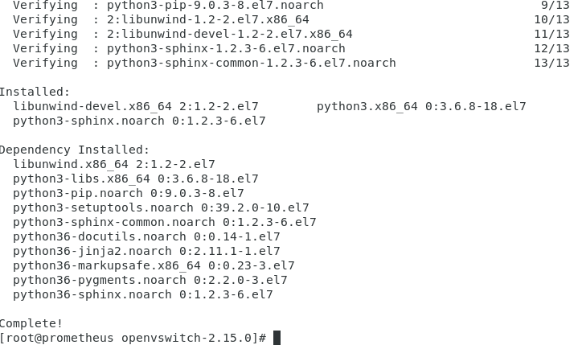

Above I downloaded the necessary dependencies that are required for it.

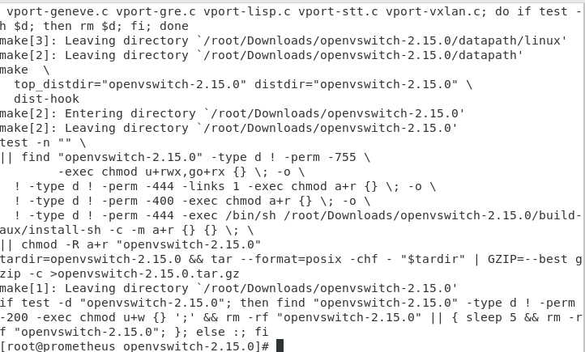

Above I run a few more commands. The make dist command creates the file that I will use for the rpm. Now that it's finished it will create a distribution tarball.



This command will create 5 directories.



Above I enter the command which will coy the new tar.z file into rpmbuild sources folder which is what I will use to create the rpm.

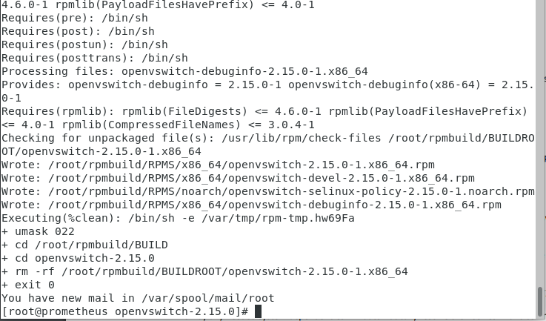

Above I ran an rpm build command which created three rpms. The rpm I am interested in is the openvswitch.

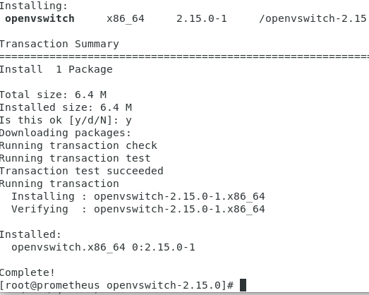

Above I have successfully installed ovs.



Above I ran the command so that it starts at system startup and starts running.

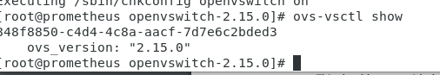

Above we can see it is successfully running.

**Ovs configuration**

Now I will be configuring the infrastructure within the cloud. To accomplish this I will need to destroy any previously built bridge and create new virtual interfaces that will be dependent on ovs.

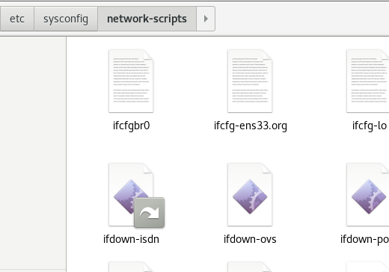

Above I moved the original en33 folder to my network scripts folder.

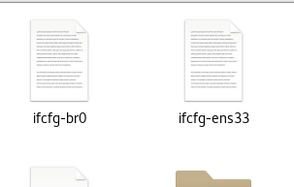

Above I moved the bridge and ifcfg-ens33 to home.

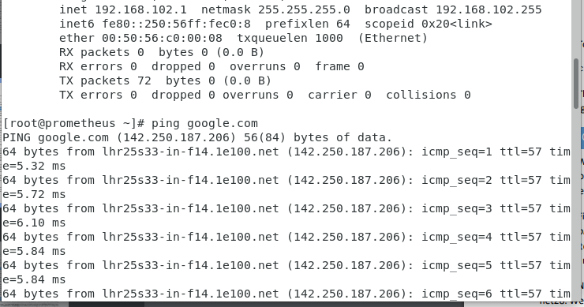

I rebooted the system and checked if I cloud ping google to see if the network configurations have been set to factory defaults. Now that's done I can move onto creating virtual network interfaces. I will start with net28. I will need to create a vmnet 28 bridge for the host to connect to network 28 and the outside world.

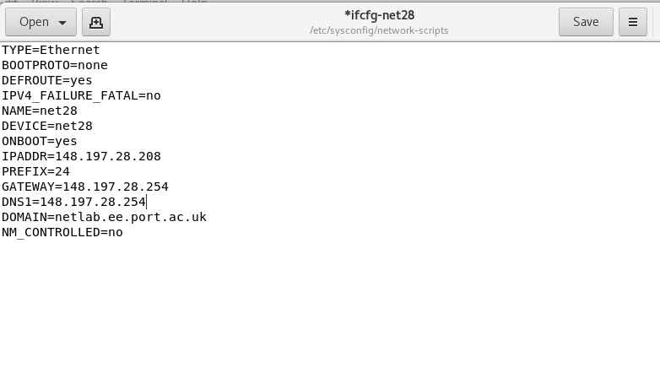

Above I have created a net28 file and made the changes based on my system details.

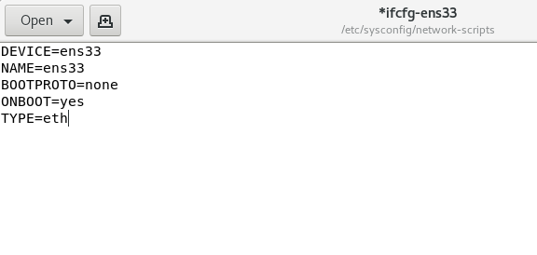

AdoVE I made changes to the ens33 config file and saved it. Now that I have these two files I can reboot the system.

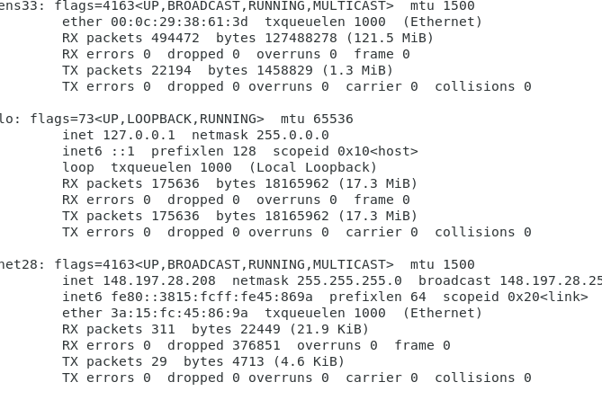

Above we can see how Inow have an ens33 and net28 network card.

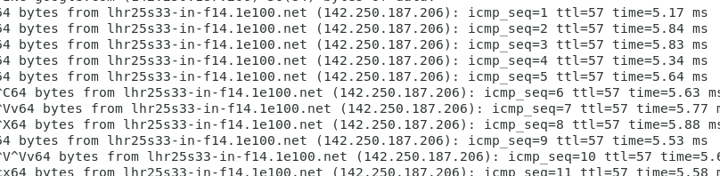

Above I doubled checked if I had internet access and successfully I can ping google.

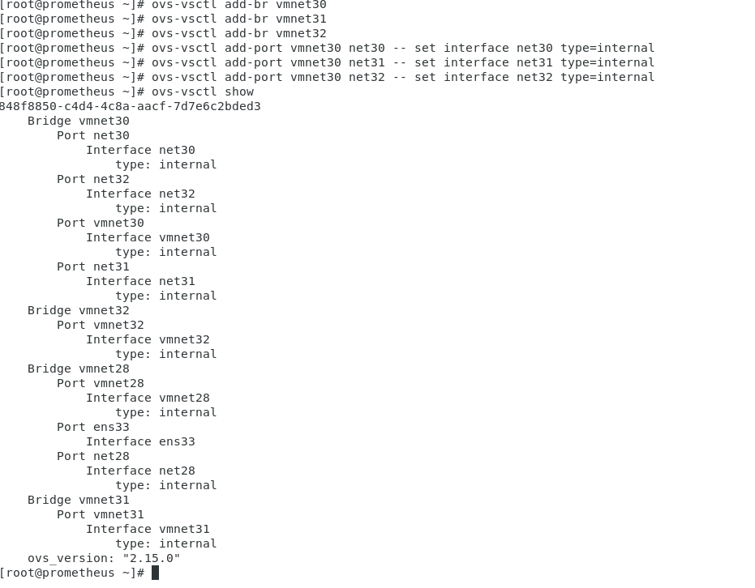

Above I java repeated the process for net30.31 and 32. I now need to create the corresponding files for the network cards.

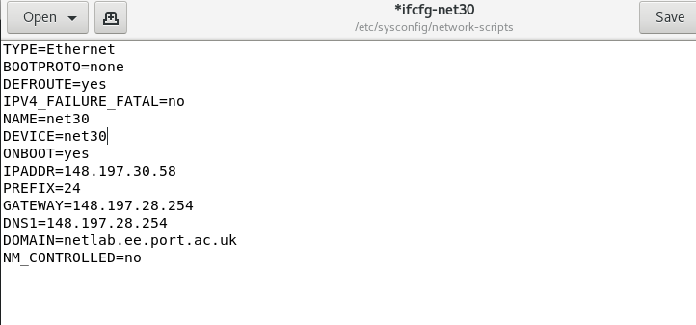

Above I have added the allocated ip address to net30.

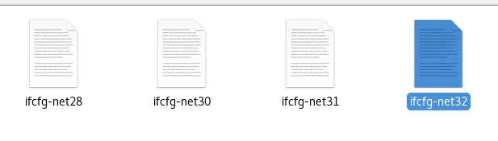

I repeated the process for the other network cards.

.